Unit 5 – Evolution Test General 2016

PART I: Matching/Multiple Choice

Directions: Circle the best answer for each question. Each question in this portion of the exam is worth 1 point.

- The main idea that stems from the theory of evolution is:
- Evolution is a theory about the origin of life.
- Evolutionary theory deals mainly with how life changed after its origin.
- Each organism is specially created.
- A mix of fossils in a region indicates that a local catastrophe occurred.

- Which of the following is NOT an example of evidence for evolution that were discussed in class?
a. Variation c. Fossil evidence
b. Biochemistry d. Anatomy

3. Based on the diagram below, in which two species would you expect to find the most similar DNA:

Chimp Human Bonobo Gorilla
Present day
10 million years ago

  - Human and gorilla
  - Chimp and human
  - Chimp and gorilla
  - Chimp and bonobo

Think of a population of lizards on an island. Which of the following would apply to the evolution of this species?

Lizards will pass on characteristics that they develop or acquire during their lives to their offspring.

Lizards will pass their DNA to their offspring
  - The most fit lizard will be the one who can get the most food
  - None of the above

The fossil record is incomplete because:

Not all the fossils were found yet

Animals with hard parts are preserved more easily and not all creatures became fossils

Both a and b

The fossil record is complete and we have all of the fossils of organisms that existed

Which of the following examples is the best example of analogous structures:

Bat wings & butterfly wings

Bat wings & whale fins

Bat wings & human arms
  - Human arms & dog leg

In evolutionary terms, “fittest” in the phrase “survival of the fittest” describes:

The fastest or strongest organisms that is able to reproduce

Those organisms that are able to survive and produce the most offspring

Those that are best able to individually develop in the environment
d. Those organisms that are the weakest and cannot reproduce

- Evolution is defined as:
  - A change in a physical trait of an individual during its lifetime
  - A change in the frequency of alleles in a population over time
  - A change in the phenotype of an individual through time
  - None of the above

- Thousands of years ago, giraffes with short necks were common amongst giraffe populations. Nearly all giraffe populations today have long necks. This remarkable difference can be attributed to:
- Giraffes were stretching their necks to keep their heads out of reach of predators
- Giraffes with naturally longer necks were able to reach higher food in the trees and therefore survive and reproduce
- Giraffes with naturally longer necks could not mate with giraffes with short necks
- Giraffes with short necks did not have the ability to reproduce

Mutations may:

Have positive effects

Have negative effects
  - Have a neutral effect
  - All of the above

- The theory of evolution by natural selection was developed by:

- Jean-Baptiste LaMarck
- Charles Darwin
- Gregor Mendel
- James Watson

The fossil record provides evidence that evolution has occurred in part because:

It shows that organisms have not changed over time

It shows how the DNA of closely related organisms is very similar

It shows that the bodies and types of organisms have changed over time
d. It shows a record of all organisms that existed

Variation drives evolution forward. Which of the following is a correct statement concerning variation?

Changes in DNA sequences occur in all organisms

Clones show a large degree of variation

Variation occurs more when an organism needs to evolve
d. The environment has no effect on the variation of an organism

- Which of the following statements about natural selection is correct?
  - Natural selection gives organisms what they need.
  - Natural selection involves organisms trying to adapt.
  - Natural selection leads to adaptations.
  - Natural selection and artificial selection are the same things.

- What is the starting point for natural selection?
  - Abundant resources are available for all organisms of a population
  - Variations that exist in a population due to mutations
  - Traits are not passed on to offspring
  - Individuals adapting to the environment

- In a population of wading birds that feed on animals and plants found in the river, the food source changes so that all that remains is deeper under water. Which types of birds will be most likely to have the most offspring?

  - Those with long beaks
  - Those with short beaks
c. Those with medium sized beaks

d. All birds will have an equal chance
for survival

- Animal breeders are trying a mate a fast growing bull with a cow that has a high milk production. They hope that the calf born will grow fast and will have a high milk yield. Name the process animal breeders practice in hope that the offspring will inherit the best features?

- Natural selection
- Artificial selection
- Fitness
- None of the above

- The table to the right shows the differences in a protein for several pairings of living organisms. Having less number of differences means the species are more closely related. According to data alone, which two animals appear to be the most closely related to humans?
Species Parings | Number of Differences
Human and chimpanzee | 0
Human and fruit fly | 29
Human and horse | 12
Human and pigeon | 12
Human and rattlesnake | 14
Human and bread mold | 48
Human and monkey | 1
Human and fly | 27
Human and turtle | 15
Human and tuna fish | 21
Human and wheat | 43

  - Chimpanzee and monkey
  - Wheat and bread mold
  - Pigeon and rattlesnake
  - Horse and pigeon

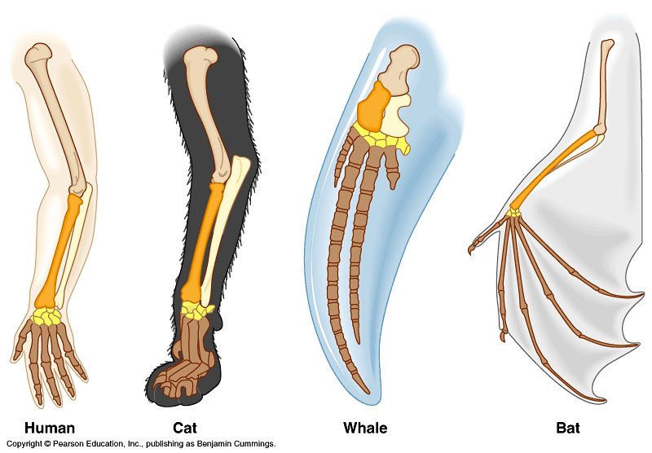
- The following picture on the right provides evidence of evolution for all of the following reasons EXCEPT:
  - These limbs all have the same structure
  - These limbs all have the same function
  - The arrangement of bones is similar in each animal
  - These homologous structures are found in a diverse group of organisms

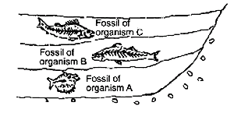
- In the photograph on the right, one could logically conclude that:
  - Fossils of organism A, B and C are all the same age
b. Fossil A is older than fossil C.
c. Fossil C is older than B
d. There is not enough information to make a
conclusion

Name:___________________________ Date: _________________ Period:____________________________

Evolution Test General 2016 PART II: Short Response
Directions: Answer three of the following four short response questions listed below. Please provide as much information as possible to answer each question. Each question in this portion of the exam is worth 5 points. The number in parenthesis at the end of each sentence indicates the point value for that portion of the question.

    - A great deal of variation exists among the walking sticks population. The population consists of brown and green colored walking sticks. Walking sticks like to live in the green bushes. Based on the data table provided below, please answer the following set of questions.
 | Green |  |  | Brown
Generation | Initial | Eaten | Survived | Initial | Eaten | Survived
Starting Population | 16 |  |  | 16
1 | 16 | 2 | 14 | 16 | 6 | 10
2 | 14 | 3 | 11 | 10 | 7 | 3
3 | 11 | 3 | 7 | 3 | 2 | 1

- What determines the success of walking sticks? (2 points)

- How did the walking stick activity demonstrate natural selection? (2 points)

- How would the population change if the walking sticks were to live in a wooden chips (brown in color) environment? (1 point)

- Cladograms are useful tools for demonstrating the evolution of a species.
- What is biological evolution? Why do scientists study cladograms? (2 points)

- Construct a cladogram to show the evolutionary relationship of the wolf, the cat, and the hamster. (3 points)
 | Cat | Hamster
Total # of DNA similarities with the Wolf | 3 | 1

______________

______________

______________

- Comparative anatomy establishes evolutionary relationships based on examining structural similarities and differences.
  - Provide a definition for both a homologous structure and an analogous structure in the box provided below. In addition, please provide one example for each. (2 points)
Homologous Structure | Analogous Structure
Definition: | Definition:
Example: | Example:

  - What is a vestigial structure? Provide one example. (2 point)

  - Explain one natural event that can result in the formation of a new species. (1 point)

- The theory that describes evolution is so strong because of the many lines of evidence that support it.
  - How does the fossil record provide evidence that evolution has occurred? Provide at least one example of fossil evidence that was discussed in class. (2 points)

  - DNA evidence can also support evolution. How does DNA evidence demonstrate that evolution occurred? (2 points)
Species Parings | Number of Differences
Human and chimpanzee | 0
Human and fruit fly | 29
Human and horse | 12
Human and pigeon | 12
Human and rattlesnake | 14
Human and bread mold | 48
Human and monkey | 1
Human and fly | 27
Human and turtle | 15
Human and tuna fish | 21
Human and wheat | 43

c. Which evidence do you feel best supports evolution? Why? (1 point)

