Name: __________________________________________________________ Date:_______
Fast Plants – Monohybrid Cross Day 1
Background
Since the dawn of agriculture, humans have been trying to improve and increase their food supply. Historically, this was done by selecting the best plants and animals, then breeding them to get the tastiest, hardiest, most nutritious, or most appealing offspring. But no one really understood how these traits were inherited. Many people believed that traits “blended” in the offspring, or that only one parent passed a trait on to its offspring. In the mid-1800’s, a monk named Gregor Mendel gathered evidence that began explaining how inheritance works. Mendel studied discrete and contrasting traits. For example, the traits that he explored in pea plants included tall vs. short plants and purple vs. white flowers. His careful, repetitious work yielded two principles of genetics: the Law of Segregation and the Law of Independent Assortment. This activity is designed for you to engage in a hands-on experiment to see evidence for these two principles.

Wisconsin Fast Plants, Brassica rapa, are widely used to study inheritance. Working in groups of four, you will germinate seeds of Fast Plants to study the inheritance of a trait (phenotype) through three generations.

Here are some symbols that you will find useful in this investigation:
P₁ – mother (maternal parent) is homozygous for color. (The female plant produces the seeds.)
P₂ – father (paternal parent) is homozygous for a different color. (The male plant provides pollen, which fertilizes ovules in the flowers of the female plant. The fertilized ovules develop into seeds.)
P₁ and P₂ plants are crossed to produce offspring.
F₁ are the offspring produced by crossing P₁ and P₂.
The F1 plants are crossed to produce the third generation of plants.
F₂ are the offspring produced by crossing the F1 plants.

F – short for filial, a word indicating offspring

Activity 1: Germinating Seeds

Your group will germinate four plates of seed disks:

Plate of Seeds | Seed Type | Number of Seeds
1 | P₁ | 16-18
2 | P₂ | 16-18
3 | F₁ | 16-18
4 | F₂ | 28-30
Decide which of you will be responsible for preparing each dish. I prepared a separate workstation for each type of seeds. You will need a pencil and a ruler. Go to the workstation for your assigned plate.

Setting Up Plates with Seed Disks
Group Name
Date
P₁

1 cm

- Use a ruler to draw a line 1 cm from the edge of a sheet of the seed disk as shown here. Place the seed disk inside the lid of a petri dish.
- Use a dropping pipet to add water to the seed disk until it is completely saturated. Drain off the excess water.
- Place the lid to on your dish. Label each dish with the date, your group’s name or number, and the seed type (e.g. P₁ or F₁)

Assemble your group’s plates and set them into a cup as shown– at a steep angle and with the 1-cm marked section at the bottom.
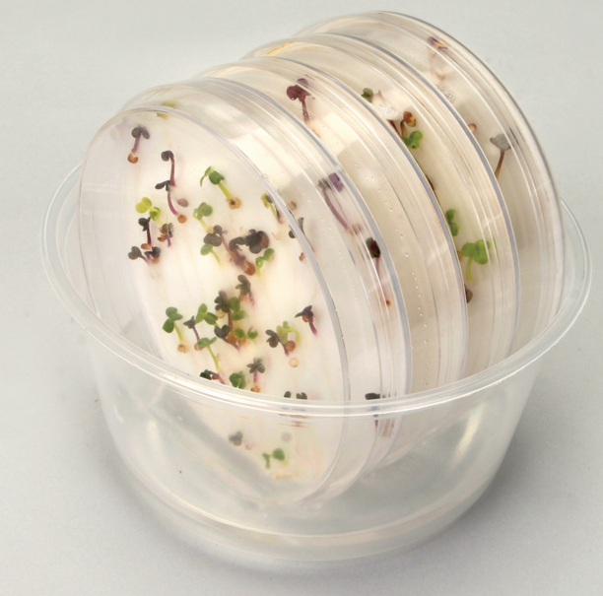
Pour water into the cup to a depth of about 1 cm. The water level should not
reach any of the seeds. If it does, rotate the petri dish.
Leave the cups with their plates where indicated by your instructor.

Over the next few days, the seeds will germinate, and the seedlings will begin to grow. Remember that the parent plants are homozygous for contrasting color phenotypes.

Plates in Germination Cup

