Name: ______________________________________ Date: __________ Period: _______

STOP & THINK
- What are genetic traits?
____________________________________________________________________________________________________________________________________________________________________________________
- List as many human traits as you can. You should have at least three.
______________________________________________________________________________________________________________________________________________________________________________________________________________________________________________________________________________

What are Heritable Traits?
- Parents and children share traits. Some traits are heritable (genetic) and some are not. Decide whether you think each of the following traits is mostly genetic or mostly not genetic. Circle your choice.

1. Eye color Genetic Not Genetic
2. Height Genetic Not Genetic
3. Hair color Genetic Not Genetic
4. Knowing French Genetic Not Genetic
5. Ability to ride a bike Genetic Not Genetic
6. Chance of developing cancer Genetic Not Genetic
7. Having mitochondria in skin cells Genetic Not Genetic
8. Being strong Genetic Not Genetic
9. Being good at football Genetic Not Genetic

What Genetic Traits do You Have?
- Write YES for each trait you have.

Dimples | Unattached earlobes | Widow’s peak | Hitchhiker’s thumb | Can roll tongue | Cleft chin | Can taste PTC

Evaluating Models of Inheritance
Your teacher will present you with several models made by other students.

5. Write down the title of each model.

Model 1: ________________________________________________________________________________ Model 2: ________________________________________________________________________________
Model 3: ________________________________________________________________________________
6. For each prediction statement, write down which model/s would lead to that prediction.

Prediction | Model
For each trait, the children will look more like mom or dad. But altogether the children will have a mix of traits from mom and traits from dad.

None of the boys will look like their mom in any respect. None of the girls will look like their dad in any respect (eye color, hair type etc.)

Children don’t really look like either of their parents. They look like a blend. Their traits will be in the middle, between parents’ traits, for all traits.

In pairs, read and discuss the evidence

7. Complete the MEL Matrix below to show how each piece of evidence relates to each model. Rate each piece of evidence in terms of its quality (on a scale of 0-3) in the little box next to each evidence picture.

Evidence Quality | Model 1 | Model 2 | Model 3

E1. Sara’s family
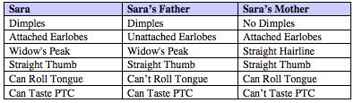

E2. Theresa’s family
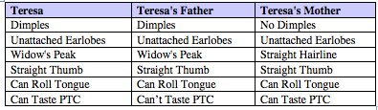

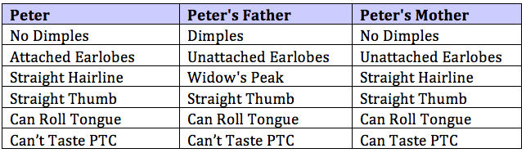
E3. Peter’s family

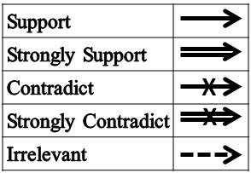

8. Individually, circle whether you kept or ruled out each model. Write the main Evidence you used to rule out the model or support it.

In pairs, discuss these questions:
- Of the models you kept, which one is the best model?
- Which evidence was most helpful in helping you choose the best model?
- Did any of the evidence contradict your chosen model?

Model 1: Ruled Out Kept
Because of Evidence #: _______

Model 2: Ruled Out Kept
Because of Evidence #: _______

Model 3: Ruled Out Kept
Because of Evidence #: _______

9. Then, individually: Write your own argument to support the model you think is best. Give detailed reasons for your answer. Write to someone who may not agree with you, but who has not seen the evidence.

__________________________________________________________________________________________
__________________________________________________________________________________________
__________________________________________________________________________________________
__________________________________________________________________________________________
__________________________________________________________________________________________
__________________________________________________________________________________________
__________________________________________________________________________________________
__________________________________________________________________________________________
__________________________________________________________________________________________
__________________________________________________________________________________________
__________________________________________________________________________________________
__________________________________________________________________________________________
__________________________________________________________________________________________
__________________________________________________________________________________________
__________________________________________________________________________________________
__________________________________________________________________________________________
__________________________________________________________________________________________
__________________________________________________________________________________________
__________________________________________________________________________________________

In pairs, discuss which model quality criteria were not met by the model you chose as the best, and by one of the models you ruled out (choose any one of them).

11. Then, write down the criteria that you think were not met by these models below:

__________________________________________________________________________________________
__________________________________________________________________________________________
__________________________________________________________________________________________
__________________________________________________________________________________________
__________________________________________________________________________________________
__________________________________________________________________________________________
__________________________________________________________________________________________

12. As a class, revise the class list of model quality criteria. Write down the new class criteria for model quality:

__________________________________________________________________________________________
__________________________________________________________________________________________
__________________________________________________________________________________________
__________________________________________________________________________________________
__________________________________________________________________________________________
__________________________________________________________________________________________
__________________________________________________________________________________________
__________________________________________________________________________________________
__________________________________________________________________________________________
__________________________________________________________________________________________
__________________________________________________________________________________________
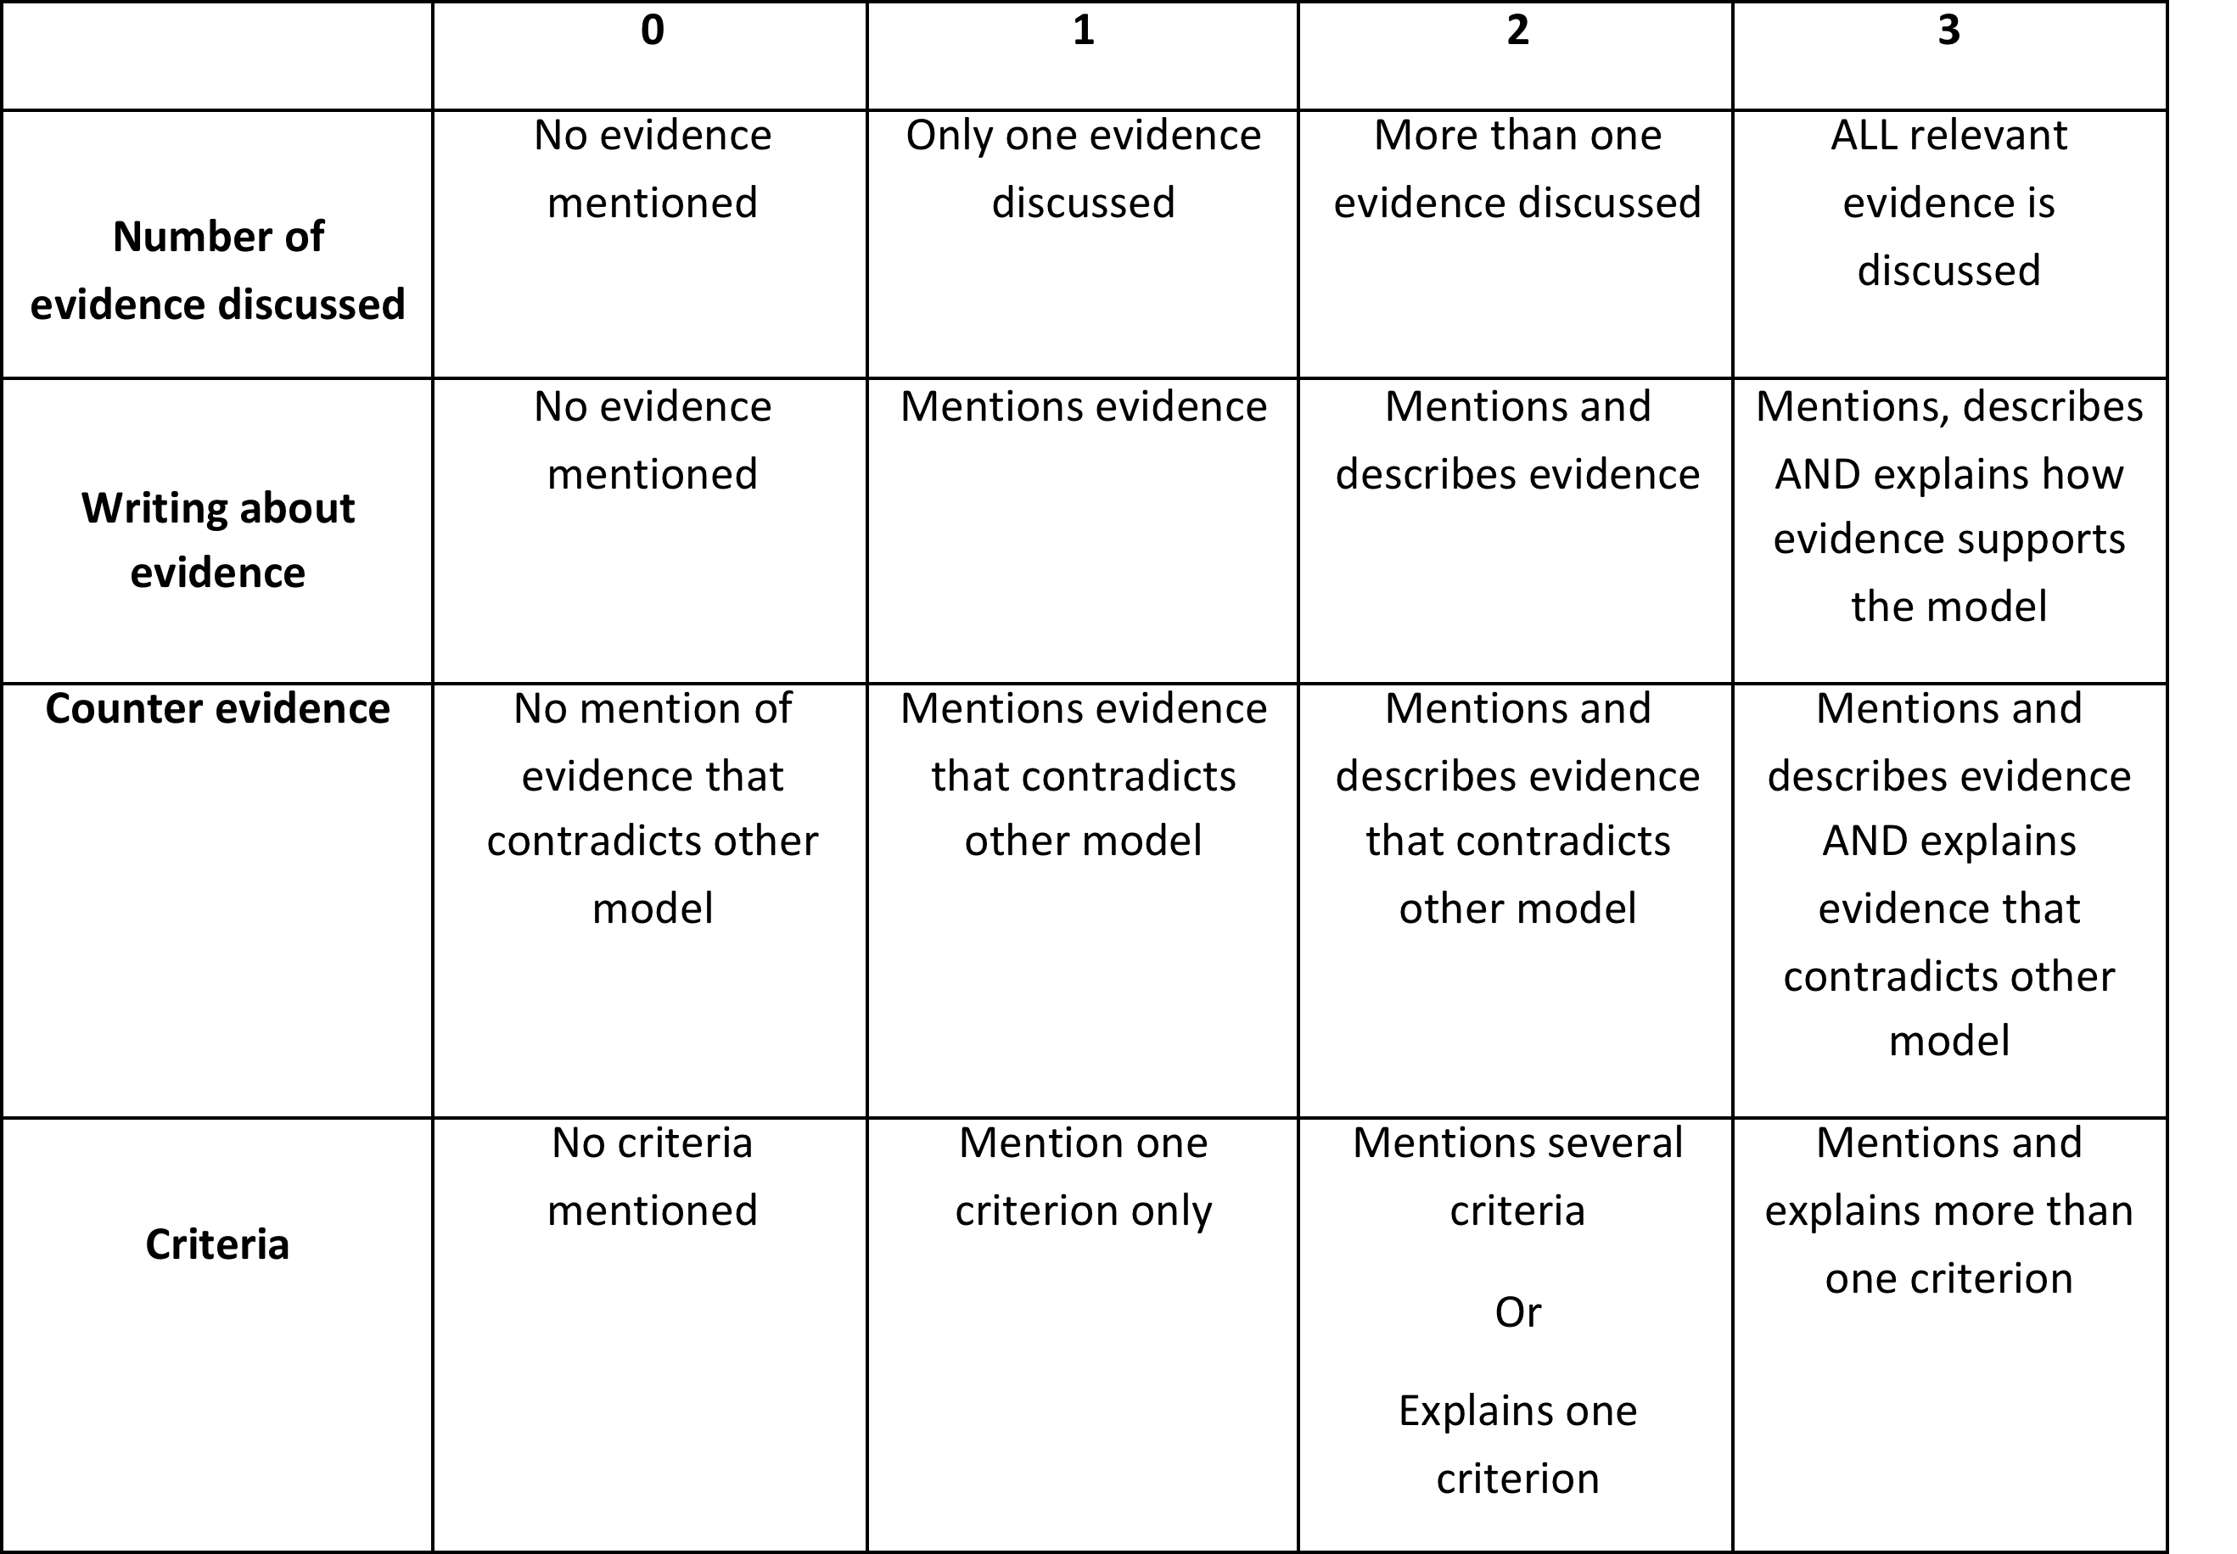
13. Use the rubric to score your argument.

