Name:____________________________________ Period:________ Date:______________
Part I. Chromosome Numbers During Division
Directions: Watch the video and answer the questions below.
https://www.youtube.com/watch?v=gcz1FOWw0Cg
- How many chromosomes are found in human body cells? _______________
- How many chromosomes are found in gametes? _______________
- Chromosomes are made up of ____________________ and ____________________.
- The image below shows a chromosome before and after replication. Label the different parts.
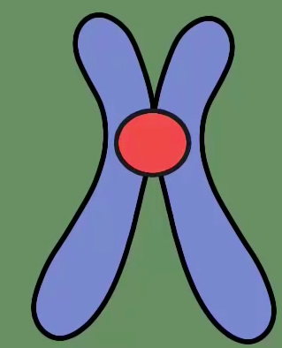

Mitosis Chromosome numbers:
 | Before Interphase | After Interphase | During Mitosis | After Mitosis
Chromosomes
Chromatids

Meiosis Chromosome numbers:
 | Before Interphase | After Interphase | During Mitosis | After Mitosis
Chromosomes
Chromatids

Part II. Concept Check
- Why do cells divide?
______________________________________________________________________________________________________________________________________________________________________________
- What happens during Synthesis?
______________________________________________________________________________________________________________________________________________________________________________
- Why is this step very important?
______________________________________________________________________________________________________________________________________________________________________________

Mitosis Phase:
- Label the following pictures with the stages of mitosis.

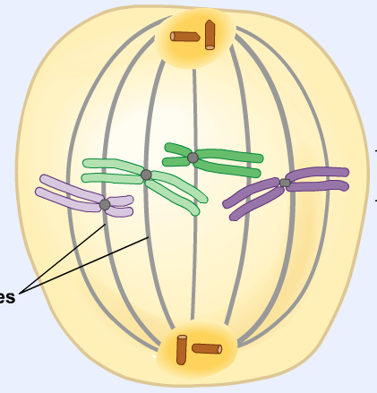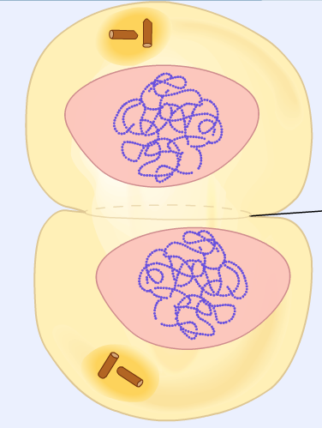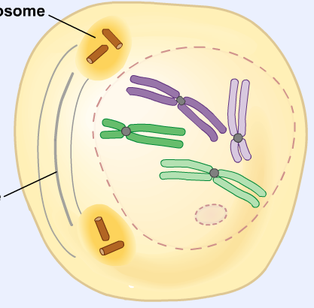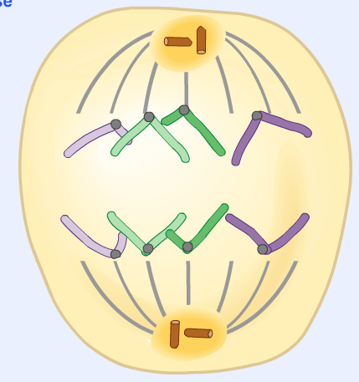
A. _____________ B. ________________ C. _______________ D. ______________

- What is the correct order? _________________________________________

