Multiple Choice:

- Stem cells can be found in everyone. They aren't specialized for any particular function in the body. Differentiation of a normal stem cell allows it to:
  - Perform the same function as other stem cells
  - Perform a specific function related to its shape, contents, and surrounding
  - Change its DNA
  - Reproduce uncontrollably

- A medical doctor is examining bone tissue from 4 human patients. He is counting the chromosomes in cells at metaphase. He observes the following:

Patient A – 46 chromosomes
Patient B – 23 chromosomes
Patient C – 47 chromosomes
Patient D – 45 chromosomes

Which patient does he determine has a normal chromosome count?
a. A b. B c. C d. D

- A zygote has:
  - Twice the genetic material of a body cell
  - Half of its DNA from the male and half from the female parent
  - Half the genetic material of a body cell
  - Genetic material from only the sperm

- Which is NOT a reason for cells to divide?

  - For growth and development
  - Repair of damaged tissues
  - Reproduction of single-celled organisms
  - Maintenance of organelles

- At some stages of the cell cycle, DNA condenses into chromosomes by wrapping around histone molecules. The main reason for this is so that:
  - The chromosomes are easier to count
  - Proteins can be produced by the DNA more easily
  - The DNA can be more easily sorted into daughter cells
  - The DNA can be easily replicated

- A sample of liver tissue is taken from a hospital patient and grown in a culture dish. It is found that over several days, the cells of the tissue have multiplied many times, completely fill the dish, and still continue to divide. The technician observing this uncontrolled cell growth concludes that this tissue:

  - Is cancerous
  - Is undergoing apoptosis
  - Contains many different types of cells
  - Contains cells that can regulate their reproduction

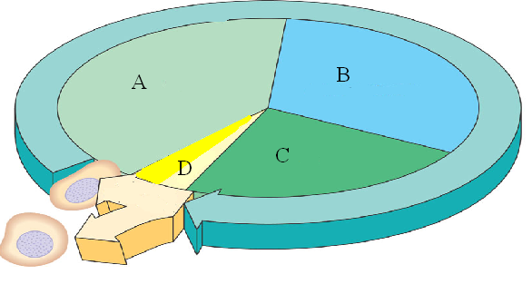
- What happens to the mass of genetic material between A-C of the diagram on the right?

  - Stays the same
  - Is reduced by ½
  - Doubles
  - Triples

- Why is the “B” phase in the above diagram so important?
  - The cell must duplicate all of its organelles
  - So that when cell division occurs, both daughter cells will have a complete copy of DNA
  - So that the cells are able to make more protein
  - So that the cell is big enough to divide in two daughter cells.

- What is the sequence of events after fertilization?

  - Zygote Gastrula Blastula Fetus
  - Zygote Blastula Gastrula Fetus
  - Sperm Blastula Gastrula Zygote
  - Gastrula Blastula Zygote Fetus

- Which process is necessary to prevent the doubling of genome size (genetic information) during sexual reproduction?

  - Mitosis
  - Apoptosis
  - Metastasis
  - Meiosis

- What is the correct sequence of events in the diagram below?
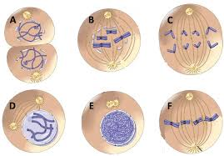
  - c, d, a, b, e, f
  - b, c, a, d, e, f
  - c, b, a, e, d, f
  - e, d, b, f, c, a

- Which of the following phases of mitosis is correctly paired with its description:
  - Metaphase – when sister chromatids are separated from each other
  - Anaphase – the nuclear membrane reforms
  - Prophase – when chromosomes condense and the nuclear membrane disappears
  - Telophase – chromosomes align themselves in the middle of the cell to prepare for division

- When the G₂/M checkpoint occurs, which of the following reasons would prevent the cell cycle from continuing?
  - Errors were detected after the cell replicated its DNA
  - Chromosomes are not correctly aligned on the metaphase plate
  - There is no need for the cell to divide
  - The spindle fibers are not properly attached to the centromeres
- If a particular strand of DNA contains 15% of Adenine, what percentage of Guanine would you find in the same strand of DNA?

  - 15%
  - 30%
  - 70%
  - 35%

- A diploid cell undergoes meiosis. What are the products of this division?

  - Four diploid cells
  - Two haploid cells
  - Four haploid cells
  - Two diploid cells

- Which of the following is NOT true about cancer cells?

  - They exhibit contact inhibition
  - They exhibit uncontrolled growth
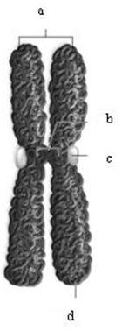
  - They exhibit disorganized growth
  - They may undergo metastasis

- Which of the following statements about the chromosome on the right is NOT true?
  - The chromosome is only highly coiled like this during cell division
  - Each half of the chromosome is genetically different from the other
  - Each half will split from the other during anaphase
  - Each half of the chromosome is genetically identical to the other

- Which of the following statements about telomeres is NOT correct:
  - Telomeres protect the ends of chromosomes
  - Part of the telomere is lost during each round of DNA replication
  - Telomeres are functional regions of coded DNA
  - Shorter telomere length is associated with a faster aging process

- DNA replication is described as a semi-conservative process because:
  - the original strands are kept intact and a new DNA molecule is synthesized with two new DNA strands.
  - a new strand is used as a template to synthesize the complementary stand. Each DNA molecule will have one new and one old strand.
  - DNA only copies itself for short chunks at a time, producing new strands that alternated parent and daughter DNA
  - the telomeres are shortened during each subsequent copying process

- Which of the following statements about cloning is correct:
  - Cloned animals live shorter lives compared to naturally bred animals
  - Cloned animals have longer telomeres compared to naturally bred animals
  - Cloning is currently an impossible process, but scientists are hoping to soon be successful
  - Immediately after successful cloning, you will have two fully grown and identical individuals

Short Response:
Control of the Cell Cycle
- With careful controls (checkpoints) in place, a cell is able to successfully navigate a complex reproductive cycle or shut it down if a problem is detected. If these controls break down, diseases such as cancer may occur.
  - Name and describe the three checkpoints and what they do. You may use a diagram to support your answer but you must explain it as well. (3 points)

  - When a cell detects a problem during the cell cycle it may react in two ways. Briefly describe both of the possible outcomes. (2 points)

Stem Cells
- A multicellular organism often has different cell types. However, all these cells came from identical stem cells.
  - Explain what a stem cell is. (2 points)

  - Describe the different categories of stem cells. (2 points)

  - Explain how a stem cell differentiates. (1 point)

Mitosis and Meiosis
- Mitosis and meiosis are both processes in which a cell undergoes division.
  - What is the purpose of mitosis? What is the purpose of meiosis? (1 point)

  - A given animal cell has 4 chromosomes. If a cell goes through mitosis, what would be the end product? Briefly describe this process (how many daughter cells, how many chromosomes in each). You may use a diagram to support your answer but you must explain it as well.
(2 points)

  - If the same animal cell goes through meiosis, what would be the end product? Briefly describe this process (how many daughter cells, how many chromosomes in each). You may use a diagram to support your answer but you must explain it as well. (2 points)

Ethical implications of stem cell therapies
- Embryonic stem cells promise to revolutionize medical treatments for certain conditions.
  - Discuss how stem cells may be used for such treatments. Use specific examples of conditions that potentially could be treated with stem cells. (3 points)

  - Discuss the ethical implications to developing such treatments using embryonic stem cells. Explain why using embryonic stem cell use is so controversial. Make sure to address pros as well as cons of embryonic stem cell therapies. (2 points)

