Name ______________________________________ Period _______ Date ____________________
Sex-Linked Pedigree Worksheet
Background:
Human somatic cells contain 46 chromosomes or 23 pairs. The first 22 pairs of chromosomes are called autosomal chromosomes. The 23rd pair is called sex chromosome as it helps determine the sex of the child. During meiosis, one copy of each of the chromosomes is passed on to our gametes (sex cells). During fertilization, the genes from both gametes combine to determine the genotype of the child.

A pedigree is a diagram of family relationships that uses symbols to represent the people and line to represent genetic relations. It is a tool to determine if the genes were passed down on the autosomal chromosomes or sex chromosomes. Individuals in a family who are affected by a disease or have a particular trait are shaded in.

The modes of inheritance discussed in this worksheet include:
Autosomal dominant: Need only one dominant allele to have the disorder/trait (A). Females and males are affected equally.

Autosomal recessive: Need two copies of the recessive allele to have the disorder/trait (aa). Female and male are affected equally.

X-linked dominant: Gene is located on the X-chromosome. Need only one dominant allele to have the disorder/trait (X^{A}). All daughters of an affected male will be affected since the father has only the affected allele to give.

X-linked recessive: Gene is located on the X-chromosome. Need two copies of the recessive allele to have the disorder/trait (XªXª). The disorder/trait will not appear when there is a normal copy of the gene. Males that inherit the mutant allele will have the disorder/trait (XªY). Disorder/trait will affect more males. Women are rarely affected but tend to be carrier (X^{A}Xª).

Part I. Analyzing Pedigrees
- Cystic fibrosis (CF) is an autosomal recessive disease where thick, sticky mucus develops in the lungs, liver, and the pancreas. Below is a pedigree tracing the passing of the CF gene though generations.
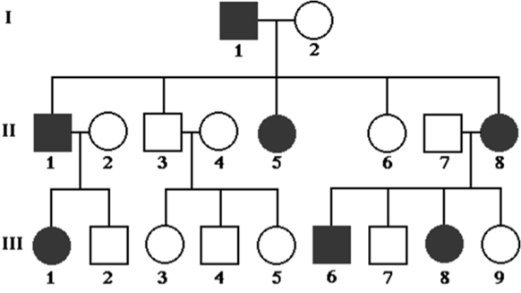
  - What is the phenotype of I-1?
______________
  - What is the phenotype of II-3?
______________
  - What is the genotype of following
individuals?

- Individual II-4 __________
- Individual II-6 __________
- Individual III-5 _________

  - In the second generation, why are individuals 1,5, and 8 affected but not 3 and 6?
_________________________________________________________________________________
- Huntington disease is a progressive brain disorder that causes uncontrolled movements, emotional problems, and loss of thinking ability. This condition is inherited in an autosomal dominant pattern. Below is a pedigree tracing the passing of the Huntington gene through three generation.

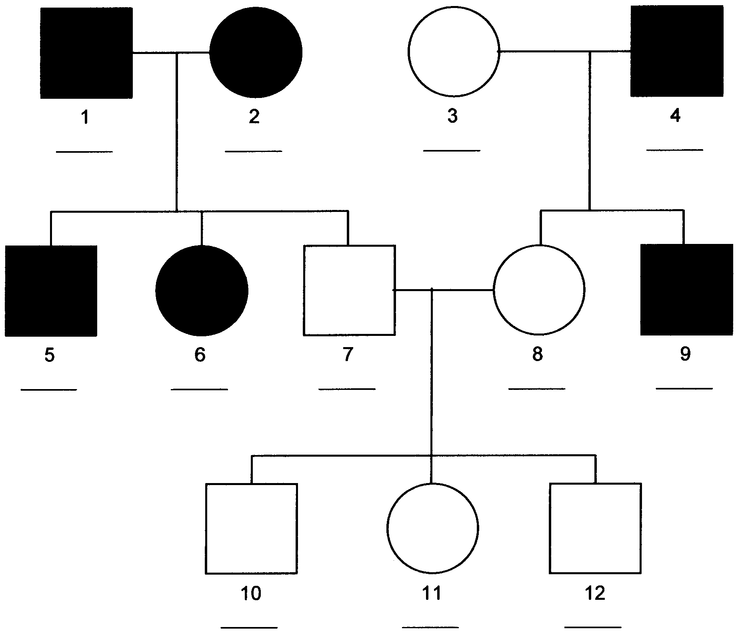
  - Label the possible genotype(s) of all the individuals on the line under the individual.

  - If individual 9 married a woman without the disorder, then what is the chance them having a child with the disorder? Show your work.

  - What is the chance of individuals 7 and 8 having a child with the disorder? Explain your answer. ______________________________________________________________________________________________________________________________________________________________________________________________________________________________________________________

- Hemophilia is an x-linked recessive disorder that slows the blood clotting process. People with this condition experience prolonged bleeding or oozing following an injury, surgery, having a tooth pulled. In severe cases, continuous bleeding occurs even in absence of injury (spontaneous bleeding).
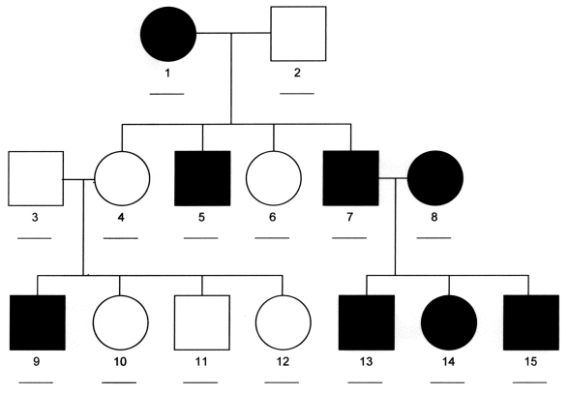

  - Label the possible genotype(s) of all the individuals on the line under the individual.

  - Which individuals are definitely carriers of the hemophilia gene? Indicate them on the pedigree appropriately.

  - Individual 6 marries a man with hemophilia.
    - What is the chance that they will have a child with hemophilia? ______________

    - What is the chance that they will have a boy with hemophilia? ______________

    - The couple has a baby girl. What is the chance that she does not have hemophilia?
______________

- Color vision deficiency, more commonly known as color blindness, is an X-linked recessive disorder that affects the perception of color. Not being able to distinguish between red and green colors is the most common form of color vision deficiency. The following pedigree traces the passing of the mutation for color vision deficiency through generations.

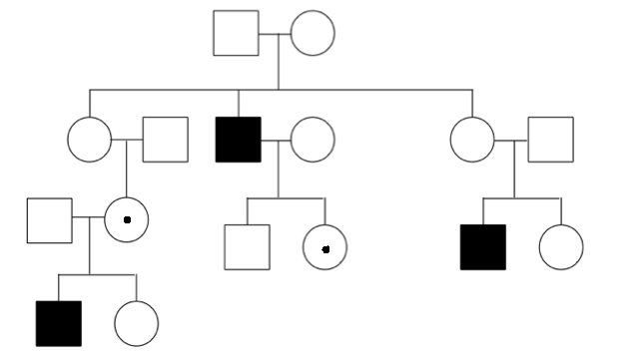

  - Number each generation and each of the family members. Follow the rules discussed in class.
  - Label the possible genotype(s) of all the individuals.
  - In this family, why are only males affected?
__________________________________________________________________________________________________________________________________________________________________
  - Which individuals are definitely carriers of the mutated gene? Indicate them on the pedigree appropriately.
- Fragile X syndrome is a genetic condition that causes a range of developmental problems including learning disabilities and cognitive impairment. It is an X-linked dominant disorder. Below is a pedigree showing the inheritance of the mutated gene in a family.

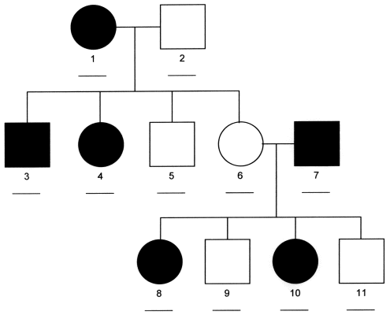
  - Label the possible genotype(s) of all the individuals on the line under the individual.

  - Are there any individuals who are carriers? Explain why or why not.
________________________________________________________________________________________________________________
________________________________________________________________________________________________________________
____________________________

  - If individual 4 has a child with normal man, what is the chance that child has the disorder?

  - Can individual 7 have a healthy daughter? Explain your answer.
__________________________________________________________________________________________________________________________________________________________________________________________________________________________________________

The following pedigrees show the passing of a disorder through generations. Determine the mode of inheritance of each of the pedigrees and answer the questions that follow.

- Is the following disorder passed on the autosomal chromosome or the X chromosome?
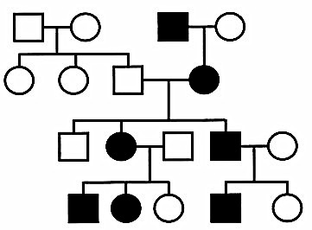
- Number each generation and each of the family members. Follow the rules discussed in class.
- Mode of inheritance: _________________________________
- Explain why it cannot be the other mode of inheritance. Use specific members from the pedigree in your explanation. ______________________________________________________________________________________________________________________________________________________________________________________________________________________________________________________

- Is the following disorder is passed via autosomal dominant, autosomal recessive, X-linked dominant or X-linked recessive inheritance pattern?
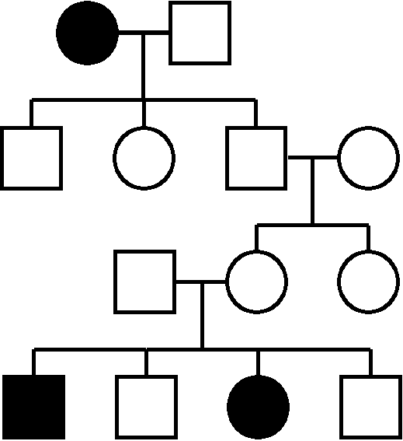
- Number each generation and each of the family members.
- Label the possible genotype(s) of all the individuals on the pedigree.
- What is the mode of inheritance?
_________________________________
- If the female from the fourth generation marries a man with the disorder, what is the chance that they will have a healthy child? Show your work.

Part II. Creating Your Own Pedigree
- Brown eyes (B) are a dominant eye-color allele and blue eyes (b) are recessive. A brown-eyed woman whose father had blue eyes and whose mother had brown eyes marries a brown-eyed man whose parents are also brown-eyed. They have a son who is blue-eyed.
  - Please draw a pedigree showing all four grandparents, the two parents, and the son.
  - Label the possible genotype(s) of all the individuals under the individual.

- Jack and Jill have five children, 2 girls and 3 boys. The Jill is a carrier of hemophilia, an X-linked recessive disorder. She passes the gene on to two of the boys who died in childhood and one of the daughters is also a carrier. Both daughters marry men without hemophilia and have 3 children (2 boys and a girl). The carrier daughter has one son with hemophilia. The non-carrier daughter’s older son marries a woman who is a carrier, and they have twin daughters.
  - Please draw a pedigree showing all family members.
  - Label the possible genotype(s) of all the individuals under the individual.
  - What is the percent chance that the twin daughters will also be a carrier? Show your work.

