The Human Body & Orientation 2 Name: ___________________
Anatomy & Physiology Homework Period: __________________
Chapter 1 Date: ____________________

Maintaining Life

Select different colors for the dorsal and ventral body cavities. Color the coding circles below and the corresponding cavities in part A of Figure 1.
Complete the figure by labeling those body cavity subdivisions that have a leader line.

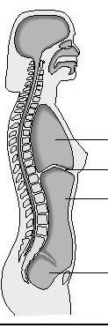 | Ventral  Dorsal

Complete part B by labeling each of the abdominal regions indicated.
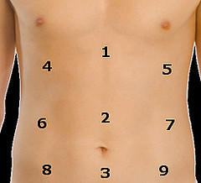 | Identify the body cavity subdivisions:  1. ________________________________________  2. ________________________________________  3. ________________________________________  4. ________________________________________  5. ________________________________________  6. ________________________________________  7. ________________________________________  8. ________________________________________  9. ________________________________________

