- HOW ARE LIVING THINGS ORGANIZED?

The cell is the basic building block of all living organisms. Some organisms will remain single celled, while others will multiply into highly specialized, multicellular organisms.
Cells themselves are made up of lots of chemicals grouped in different ways, and the cells and the chemicals that make them are all highly organized, from simple to complex:

Atoms: This is the basic unit of any chemical, such as Carbon, Hydrogen, Oxygen
Molecules: Groups of atoms can be joined to create molecules, for example, two hydrogen atoms and one oxygen atom will join together to create a water molecule.
Macromolecules: Some simple molecules join together to form large complex molecules, such as amino acids that join together to make proteins.
Organelles: Macromolecules combine to form structures in cells, such as membranes and mitochondria, with each organelle carrying out a specific job or function.
Cells: The basic unit of all living organisms, such as a muscle cell, leaf cell, nerve cell.

WATER
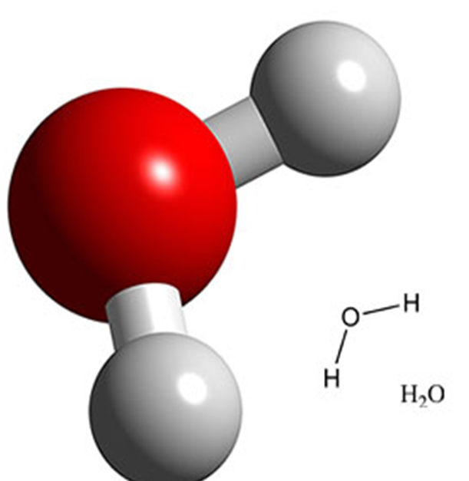
Water is composed of one oxygen atom and two hydrogen atoms.
Water is a "polar" molecule, meaning that there is an uneven distribution of electron density. Water has a partial negative charge near the oxygen atom, and partial positive charges near the hydrogen atoms.
Attraction between the partial positive charge near the hydrogen atoms and the partial negative charge near the oxygen results in the formation of a hydrogen bond.
About two-thirds of the weight of cells is accounted for by water.
The properties of water:
- Water as a solvent: Water dissolves so many compounds that it is called the "universal solvent". When water dissolves a substance it pulls it apart ion by ion.
- Water as a molecule with cohesive properties: The hydrogen bonds in water mean that the water molecules have considerable cohesive properties (molecules of water stick together). This cohesion allows plants to pull water up from the roots to the leaves. It is also important in the formation of surface tension, which enables insects such as pond skaters to move across the surface of the water without sinking.

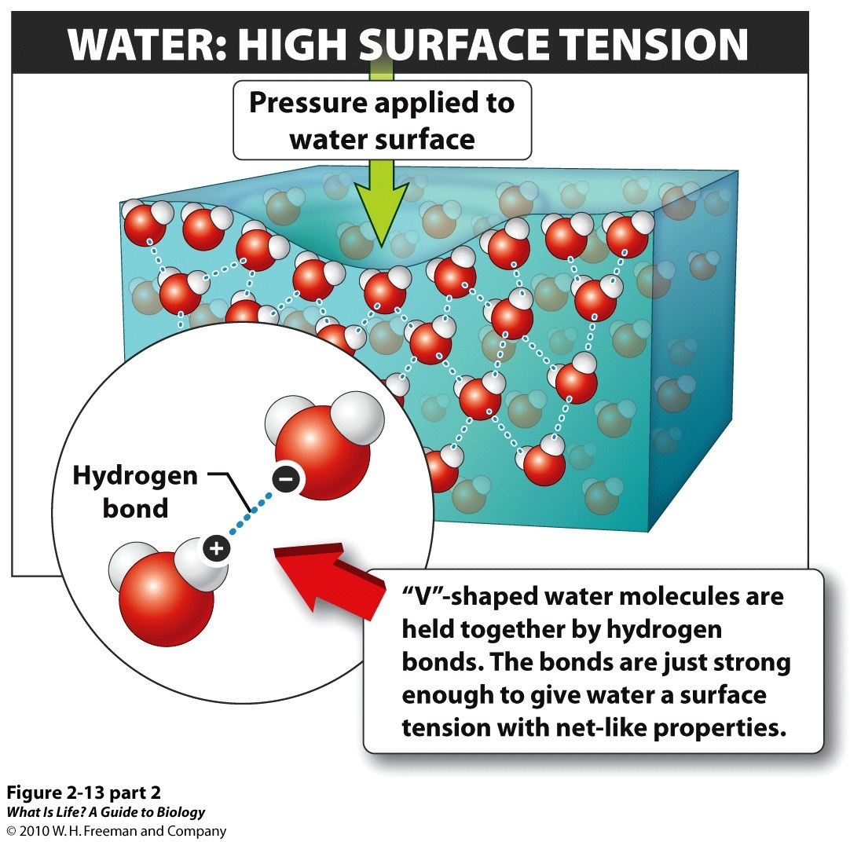
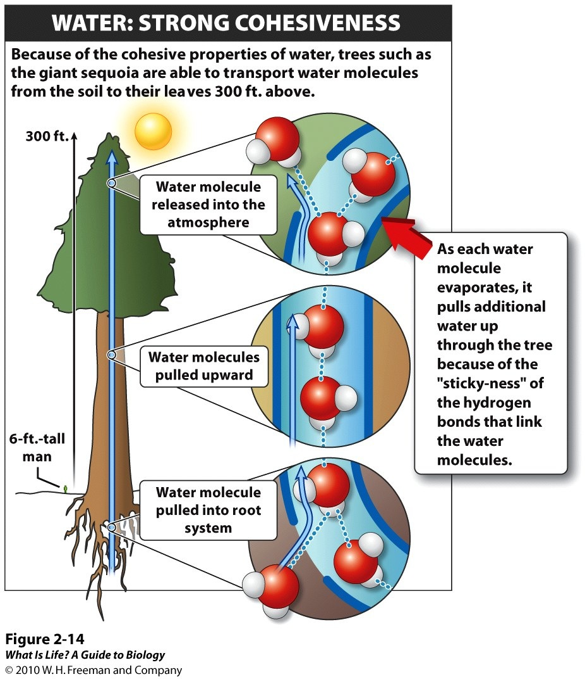
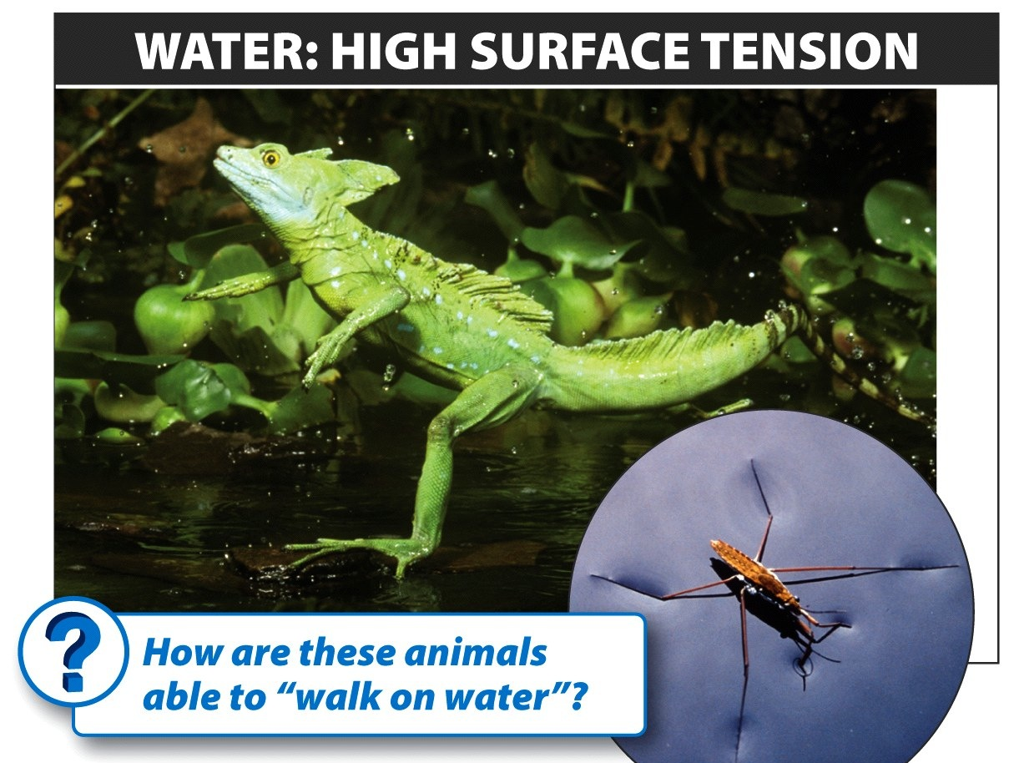

- Water as a molecule with adhesive properties. Water molecules adhere to other surfaces.

CELLS
Cell Theory:
- All living things are composed of one or more cells.
- Cells are the basic units of structure and function in an organism.
- Cells come only from the reproduction of existing cells.
All cells can be placed in two categories.

- A eukaryotic cell:
• DNA contained in nucleus
• Internal structures organized into compartments
• Larger than prokaryotes—usually 10 times bigger
• Cytoplasm contains specialized structures called organelles

- A prokaryotic cell:
- No nucleus—DNA is in the cytoplasm
• Internal structures not organized into compartments
• Much smaller than eukaryotes

Eukaryotic cells can be divided into animal and plant cells:
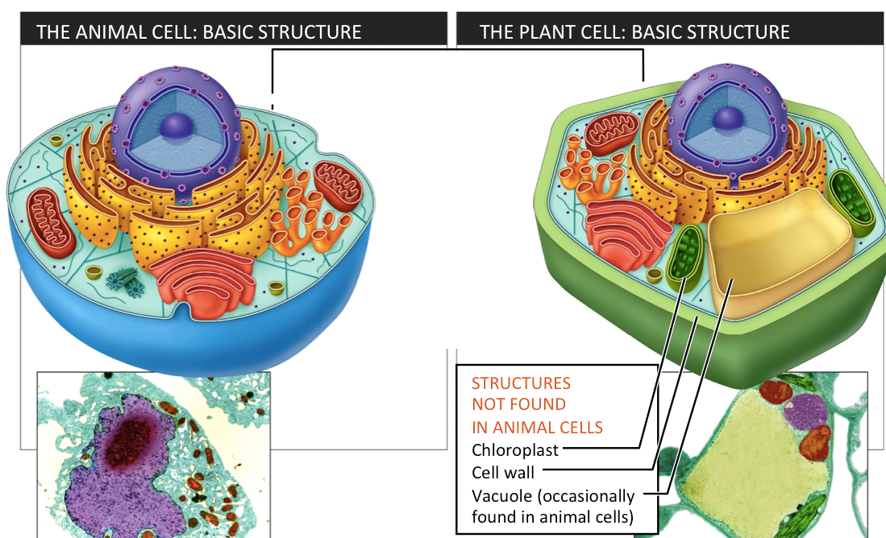

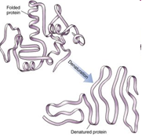
HOMEOSTASIS
The maintenance of a constant environment in the body is called Homeostasis
Cells work best if they have a correct and constant environment, e.g.
  - Temperature
  - pH level
  - Oxygen level
  - Glucose concentration, etc.
All organisms have mechanisms to keep their cells in a constant environment. If homeostasis is not working proteins may be affected (denatured).
Examples of homeostatic response:

- Heart rate is the number of heartbeats per unit of time - typically expressed as beats per minute (bpm) - which can vary as the body's need to absorb oxygen and excrete carbon dioxide changes, such as during exercise or sleep. For instance, during exercising the heart rate goes up, on the other hand, during sleep the heart rate goes down.

- Body temperature
All mammals maintain a constant body temperature.
Human beings have a body temperature of about 37ºC.
  - E.g. If your body is in a hot environment your body temperature is 37ºC
  - If your body is in a cold environment your body temperature is still 37ºC
Even if you run up and down the stairs couple of times your body temperature will remain constant.

Mechanisms to cool body down:
Sweating
When your body is hot, sweat glands are stimulated to release sweat.
The liquid sweat turns into a gas (it evaporates.)To do this, it needs heat.
It gets that heat from your skin. As your skin loses heat, it cools down.
Vasodilation
Your blood carries most of the heat energy around your body.
There are capillaries underneath your skin that can be filled with blood if you get too hot. This brings the blood closer to the surface of the skin so more heat can be lost.
This is why you look red when you are hot!

Mechanisms to warm body up:
Vasoconstriction
This is the opposite of vasodilation. The capillaries underneath your skin get constricted (shut off). This takes the blood away from the surface of the skin so less heat can be lost.
Piloerection (Does not work for humans)
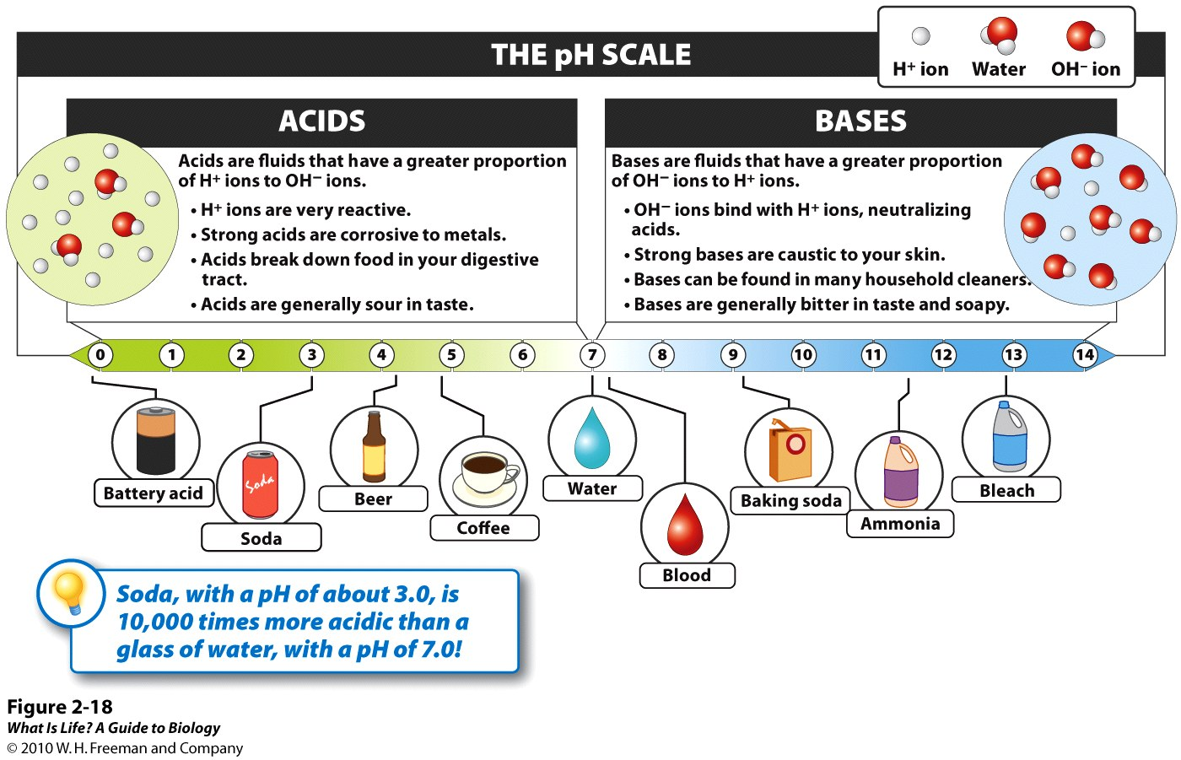
This is when the hairs on your skin “stand up”. It is sometimes called “goose bumps” or “chicken skin”! The hairs trap a layer of air next to the skin which is then warmed by the body heat. The air becomes an insulating layer.
Shivering

- Acidity level
A drastic change in pH can permanently damage the structure of proteins/enzymes. All enzymes are affected by pH changes. If the enzyme’s structure is damaged, so is its ability to function.
Analyze the graph to the right. What happens with enzyme activity when pH gets too low or too high?
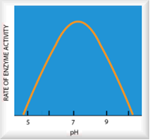
Cells die if their enzymes don’t work. Ironically, most cellular activities produce a variety of acids and bases that in turn affect pH. The cell must resist these potential pH shifts. Cells protect their enzymes by using buffering molecules also produced by the cells. A cell without the buffer will function normally only if there is no pH change.

CELLULAR TRANSPORTS
Concentration: The number of molecules of a substance in a mixture in relation to another substance in the same mixture

PASSIVE PROCESSES:

Diffusion
Molecules move from an area of high concentration to an area of low concentration – along a concentration gradient until they reach equilibrium. This requires no energy so is a passive process. Small molecules such as oxygen, carbon dioxide and water can freely pass through a plasma membrane.

Osmosis is the diffusion of water only, from an area where there is a lot of water to an area where there is less water (concentrated), until equilibrium is reached.
Solution=solute+solvent
A solution is a homogeneous mixture composed of two or more substances.
In such a mixture, a solute (tonic) is dissolved in another substance, known as a solvent.
Solute is the dissolved matter in a solution.
The most common solvent in everyday life is water.

Hypertonic solution = high % of solute, low % of water
Hypotonic solution= low % of solute, high % of water
Isotonic solution = same concentration of solute and water as compared to another solution
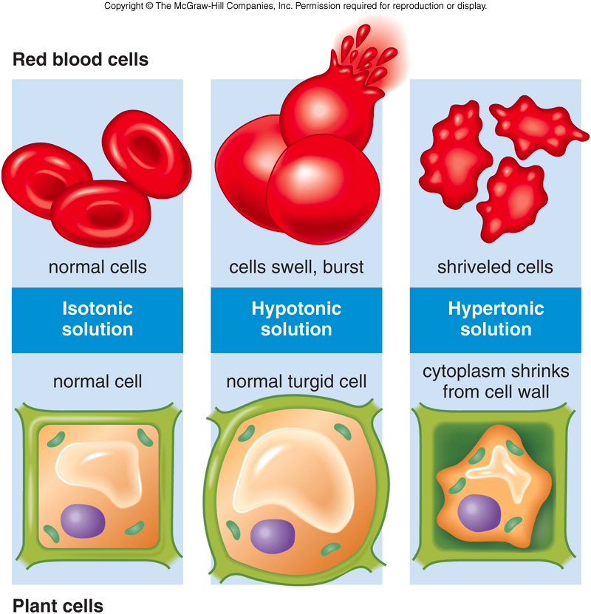
CRENATION
LYSIS
PLASMOLYSIS

ACTIVE PROCESSES:

Move substances against a concentration gradient, from an area where there is little to an area where there are already a lot. This requires energy. This is how plants move minerals from the soil and how our kidneys filter sugar and useful substances back into our blood. The molecules through which large or charged particles may enter or leave the cell by are mostly made of proteins.
Sodium-Potassium Pump is a type of protein which transports sodium (Na⁺) and potassium (K⁺) ions up the concentration gradient. This mechanism uses energy.
Endocytosis is a process by which molecules or particles are engulfed by the cell membrane and drawn within the cell. This always requires energy and so is a form of active transport requiring ATP.
Exocytosis is a process by which molecules or particles from the inside of the cell are released to the outside of the cell. This always requires energy and so is a form of active transport requiring ATP.
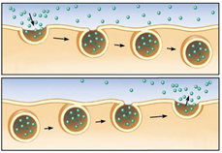
Endocytosis

Exocytosis

PLEASE REVIEW ALL THE LABS WE HAVE DONE

1. Osmosis Diffusion Lab (What molecules moved? What direction?)
2. Acid Base Lab (What substances resisted changes in pH best? Why?)

