Name _____________________________________ Period ____ Date ______
Mendelian Genetics Study Guide
Note: This study guide does not cover all activities we completed in class. You must review everything we have discussed in unit 3 to successfully pass this test.

Use Quizlet to study all of the vocabulary associated with this unit.
Sign up for this class at: https://quizlet.com/join/Zg9Qrg2mQ

Use this Fact bank for all questions:
Dimples (D) are dominant to no dimples (d)
Freckles (F) are dominant to no freckles (f)

- A male is heterozygous for dimples and a female is homozygous dominant for dimples
  - What are all of the possible genotypes from a cross? ____________________________
  - What are all of the possible phenotypes for this cross? __________________________
  - Show your results in a Punnett Square.

- Human males and females differ genetically by chromosome #23.
  - How are these chromosomes different? ________________________________________________
  - Why are males more susceptible to recessive disorders on this chromosome? __________________
_______________________________________________________________________________
_______________________________________________________________________________

- Use this pedigree to determine how the following individuals are related:

A

- What are homologous chromosomes?

______________________________________________________________________________________________________________________________________________________________________________
- How many chromosomes do our somatic cells contain? ________
- How many chromosomes do our gametes (sex cells) contain? ________
- The muscle cells of a dog have 78 chromosomes. How many chromosomes are in a dog’s:

  - Bone cells __________
  - Liver cells __________
  - Somatic cell __________
  - Sperm cell __________
- Explain why our cells must duplicate the DNA molecules before they divide?
______________________________________________________________________________________________________________________________________________________________________________
- Label the diagram below using the following terms:
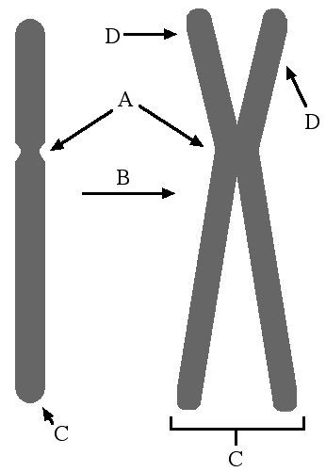
_______ Chromosome
_______ DNA replication
_______ Centromere
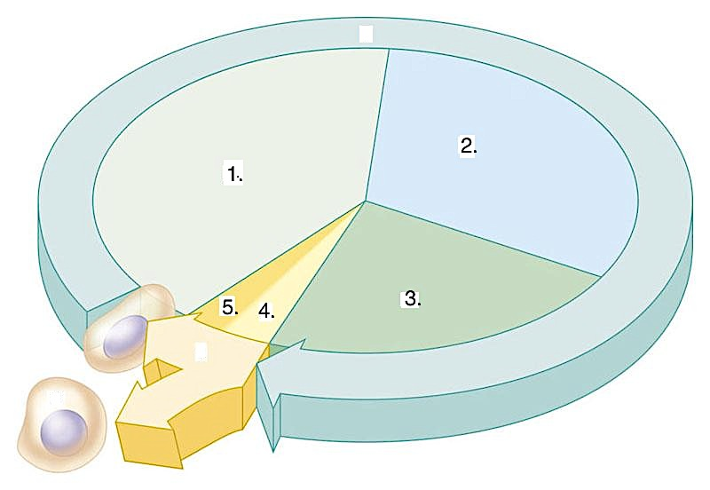
_______ Sister Chromatid

- Complete the table using the diagram of the typical eukaryotic cell cycle. (Picture on the right)

 | Stage | What happens during this stage?
I  N  T  E  R  P  H  A  S  E | - _________________
 | - _________________
 | - _________________ | What happens to the mass of genetic material during this stage?
- _________________ |  | What is the physical appearance of chromosomes during this stage?
- _________________

- Explain what needs to happen before the cell can go through mitosis.
______________________________________________________________________________________________________________________________________________________________________________
- Draw a chromosome before and after the S phase.

- When are condensed chromosomes first visible during a cell cycle? __________________________________

- Complete the following table comparing MITOSIS with MEIOSIS.

 | What is the purpose of this process?  (When would this process take place?) | How many cells are produced as a result of this process? | What happens to the number of chromosomes in the new daughter cells? | Are the daughter cells genetically identical to the parent cell or unique?
MITOSIS
MEIOSIS

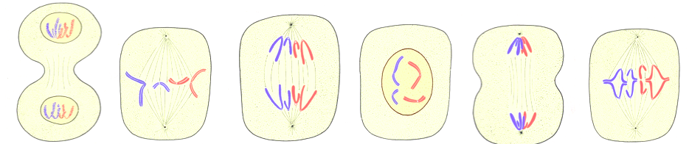
- The diagram below represents cells at various stages of mitosis. Identify and label each of the stages in this diagram. Use the following terms: prophase, metaphase, anaphase, telophase

- Match the following steps of the mitosis with the appropriate description.
__ Prophase | - Chromosomes move to the center of the cell and line up along the equator.
__ Telophase | - Nuclear envelopes form around chromosomes at each end of the cell.
__ Metaphase | - Chromosomes condense and become visible.

__ Anaphase | - Sister chromatids separate and move toward opposite poles of the cell.
- Why do chromosomes become more condensed by wrapping around the histone proteins during the cell cycle?
______________________________________________________________________________________________________________________________________________________________________________
Use the diagram below to answer the questions that follow.

- Why must cells go through checkpoints?
______________________________________________________________________________________________________________________________________________________________________________
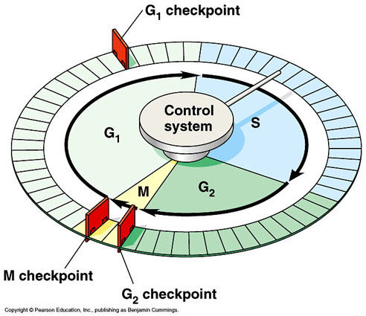
- Explain what happens in each of these three checkpoints.
____________________________________________________________________________________________________________________________________________________________________________________________________________________________________________________________________________________________________________________________________________________________________________________________________________________________________________________________________________________________________________________
- If a problem occurs in the cell cycle, what can the cell do?
______________________________________________________________________________________________________________________________________________________________________________
- What is apoptosis?
______________________________________________________________________________________________________________________________________________________________________________
- What is the relationship between apoptosis and cancer?
_______________________________________________________________________________________

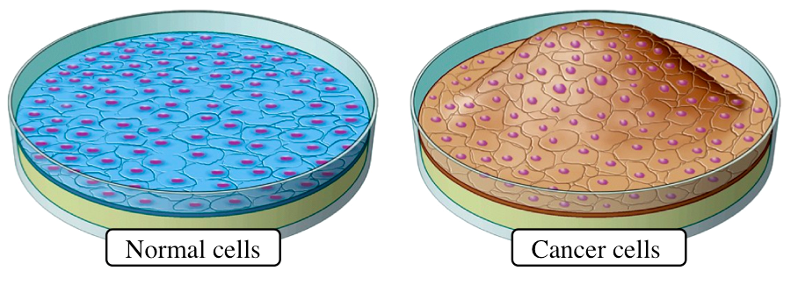
- Cancer cells have several features that distinguish them from normal cells. Describe two characteristics of cancer cells. Hint: Look at the pictures below.
________________________________________________________________________________________________________________________________________________________________________________________________________

- What is cell differentiation?
______________________________________________________________________________________________________________________________________________________________________________
- What are stem cells?
______________________________________________________________________________________________________________________________________________________________________________
- Stem cells can be organized in different categories based on their origin and the amount of potential to become other cells. Use the diagram below to answer the following questions:

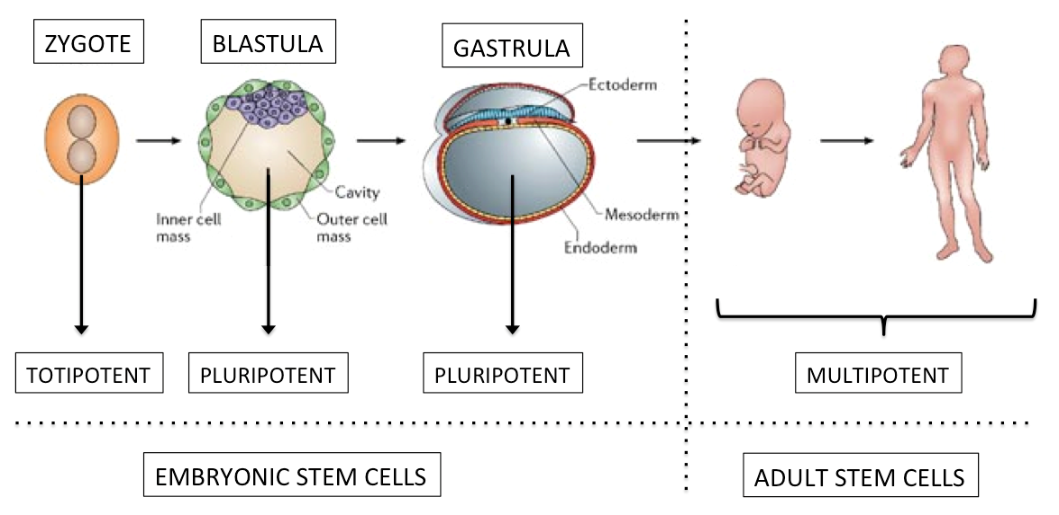
Stem cells that can differentiate into any types of cells are said to be: _________________________________
Stem cells that can differentiate into most of the types of cells are said to be: ___________________________
Stem cells that can differentiate into only few types of cells are said to be: _____________________________
Multipotent stem cells can be found in: ________________________________________________________
Pluripotent stem cells can be found in: ________________________________________________________
Totipotent stem cells can only be found in: _____________________________________________________

- Discuss how stem cells may be used for such treatments. Use a specific example of a disease/disorder that could be treated using stem cells. ____________________________________________________________________________________________________________________________________________________________________________________________________________________________________________________________________________________________________________________________________________________________

- Why is the use of stem cells so controversial?
________________________________________________________________________________________________________________________________________________________________________________________________________________________________________________________________________________________________________________________________________________________________________
- Define cloning.
________________________________________________________________________________________________________________________________________________________________________________________________________________________________________________________________________________________________________________________________________________________________________
- List the steps used in the cloning of Dolly the sheep.
1. ___________________________________________________

2. ___________________________________________________

3. ___________________________________________________

4. ___________________________________________________

5. ___________________________________________________

6. ___________________________________________________

