Unit 1 Retest – Cell Maintenance and Membrane Transport (Lab)
Cell Theory
- The following is true about the cell theory:
- Cells are the basic unit of all living things |  | - All cells are the same size and shape
- All cells have organelles |  | - All cells have a nucleus

- The structural and functional unit of all living organisms is the:
- Cell |  | - Organelle
- Organ |  | - Atom

Homeostasis
- The principle of homeostasis would account for which of the following conditions:
- High external temperature causes internal body temperature to rise |  | - High external temperature causes internal body temperature to fall
- High external temperature causes internal body temperature to remain the same |  | - High external temperature causes internal body pH to change

- Buffers are needed for homeostasis because:
- Buffer proteins make Amino Acids |  | - Buffers prevent fluctuations in the cell that cause pH to rise.
- Proteins only function in a narrow range of pH, and buffers prevent pH changes. |  | - Buffers are necessary for osmosis of proteins across a selectively permeable membrane.

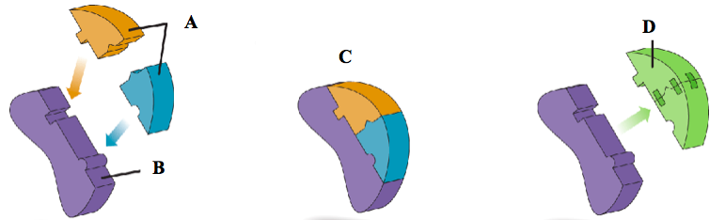

- Look at the diagram above. What is the part labeled “B” known as?
- Enzymes |  | - Sugars
- Phospholipids |  | - Amino Acids

- The monomer subunit that carbohydrates are made of are:
- Enzymes |  | - Sugars
- Phospholipids |  | - Amino Acids

- Carbohydrates are made by:
- Mitochondria |  | - Chloroplasts
- Ribosomes |  | - Cell Walls

- A rise in body temperature would probably result in the following response:
- Vasoconstriction in the skin |  | - No change, because homeostasis means that an organism “stands still” at a “similar” level.
- Vasodilation in the skin |  | - Piloerection

- Catalase (the enzyme from our laboratory activity) which decomposes Hydrogen Peroxide into:
- Liquid Water and Oxygen gas |  | - Liquid Peroxide and Oxygen Gas
- Peroxide Gas and Liquid Oxygen |  | - Hydrogen Gas and Liquid Water

- A cell with a buffer functions correctly because:
- Cells can function regardless of the pH so long as a buffer is present. |  | - Cells regulate buffers, enzymes and reactions independently.
- Most enzymes don’t need buffers. |  | - Buffers are only needed when there is a temperature change.

Short Response: Please read the directions carefully.

- Homeostasis
Homeostasis is a defining feature of all living things. It is a state of balance that all organisms must maintain to continue living. Explain in detail how organisms’ bodies maintain constant temperature.

  - List and describe three mechanisms that the body uses to maintain Homeostasis.
Explain how they work. (3)

  - Why is it important that cells maintain a stable environment (constant pH and temperature constant)?
Be specific. Do not write, “Things won’t work”.

- Feedback
Review the following models and the questions that follow.
Model A Model B

- Which of the model shown above is the correct one? Circle one. (1)
Model A or Model B
- Explain why the other model is incorrect. You must provide at least two reasons. (2)

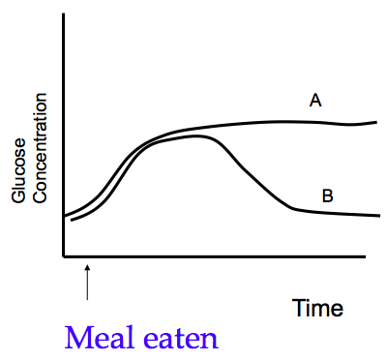
Blood Sugar Levels

- When high levels of sugar are present in the blood, what is this condition called? (1)

- Look at the graph; what does the curve A represent? (1)

