Sense Lab

- The “blind spot”…
  - Only exists for some people
  - Only exists in one eye
  - Only exists if you are looking at a small dot in your peripheral vision
  - Is usually filled in by the brain using surrounding information
- The greatest benefit to having two eyes is…
  - If something goes wrong with one, we have a backup
  - It gives us a wider field of vision
  - It helps us to see more clearly
  - It allows us to experience the world in 3D
- Which of the following statements is true?
  - Rods help you see color and Cones help you see intensity of light.
  - Cones help you see color and Rods help you see intensity of light.
  - Rods and Cones both assist in differentiating colors.
  - Rods and Cones both assist in determining the intensity of light.
- Cells in our eyes see all of the following isolated color wavelengths EXCEPT…
  - Red
  - Blue
  - Green
  - Yellow
- Which of the following visual acuities would result in the best vision?
  - 20/200
  - 20/25
  - 20/20
  - 20/15
  - 20/10
- When you enter a bright room, your pupils…
  - Dilate (become larger)
  - Contract (become smaller)
  - Stay the same size
- If you stare at the same color for too long, you may see an “afterimage” because…
  - Your brain tends to remember the last thing you looked at
  - The color receptors used have become fatigued and stop working properly
  - The color receptors used have become temporarily “burned” into your vision
- If I close one eye and try to touch my fingers together I will usually be successful because…
  - I can see just as well with one eye
  - My open eye will dilate and let in more light to compensate
  - I can use Proprioception
  - I can use Static Equilibrium
- If I do not have astigmatism and I look at the astigmatism chart, I will see…
  - All lines equally dark
  - Lines 6 and 12 darker than the rest
  - Lines 5 and 11 darker than the rest
  - A few blinking lines
- Most people with colorblindness…
  - Are female
  - See black, white, and shades of gray
  - See red items as green, and green items as red
  - Cannot tell the difference between certain colors

Neuron Structure

- The below neuron is a/an…
  - Motor Neuron & Afferent
  - Motor Neuron & Efferent
  - Sensory Neuron & Afferent
  - Sensory Neuron & Efferent
- The direction of the Action Potential for the below neuron is…
- From Cell Body toward Terminal Endings
- From Terminal Endings toward Cell Body
- Constantly alternating directions
- From axon to dendrites
- The basic unit of the Nervous System is a/an…
- Neuron
- Glial Cell
- Astrocyte
- Dendrite
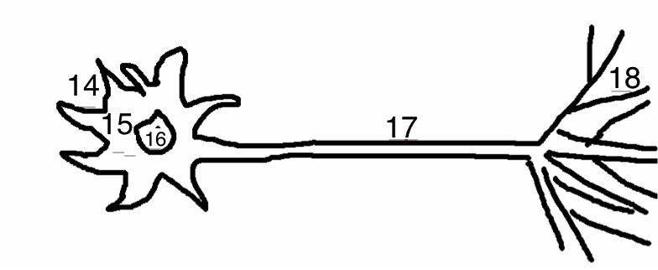
Use the diagram above to match the following terms:

A Axon B Dendrites C Cell Body D Terminal Endings E Nucleus

