Name:_____________________________ Date: _______ Period:______

Organelle Homework 2

Review cell structure.
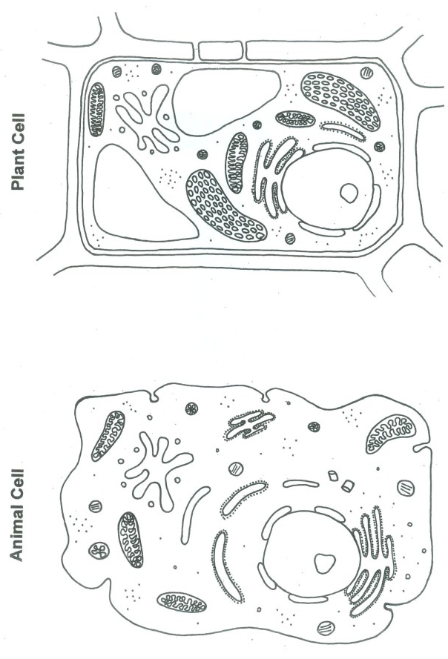
Is the cell on the left a plant cell or an animal cell? How can you tell?
Identify the organelles that are in Plant Cells but not Animal cells.
You may use the Internet or your notes for information.
Explain why plant cells need organelles that animals don't? (Why don't animal cells have the same organelles as plants?)

