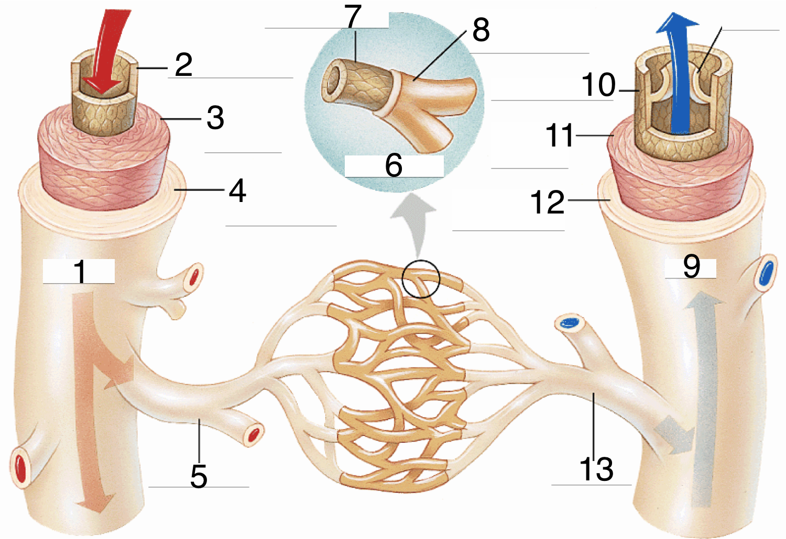

Section 1: Match the terms from the bank below to the question numbers in the above diagram.
NOTE: The diagram represents blood moving to and from the BODY.

Word Bank: Some terms are used more than once.
A Vein AB Smooth Muscle
B Artery AC Basement Membrane
C Venuole AD Endothelium
D Arteriole AE Connective Tissue
E Capillary

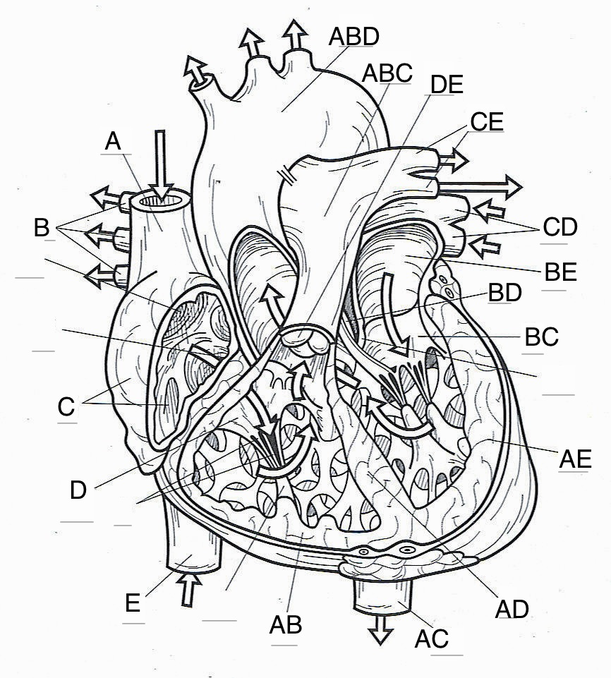

Section 2: For the following questions, refer to the above diagram and match the terms to their correct structure.

14. Right Atrium 20. Left Pulmonary Artery 26. Tricuspid Valve
15. Left Atrium 21. Right Pulmonary Artery 27. Bicuspid Valve
16. Right Ventricle 22. Pulmonary Vein 28. Aortic Semilunar Valve
17. Left Ventricle 23. Pulmonary Trunk 29. Pulmonary Semilunar Valve
18. Superior Vena Cava 24. Descending Aorta 30. Interventricular Septum
19. Inferior Vena Cava 25. Aortic Arch

Section 3: Multiple Choice
NOTE: There is only one answer per question.

31. The heart is about the size of your __________.
(A) head
(B) fist
(C) foot
(D) lungs
32. The pericardium is a fluid-filled membrane surrounding the __________.
(A) heart
(B) right and left atria
(C) right and left ventricles
(D) interventricular septum
33. The purpose of valves within the circulatory system is to __________.
(A) maintain one-way blood flow through the body
(B) maintain bi-directional blood flow through the body
(C) prevent blood from crossing the interventricular septum
(D) alternate blood flow between the lungs and body
34. Heart Failure refers to __________.
(A) a malfunction of the semilunar valves
(B) a malfunction of the pulmonary and aortic valves
(C) a complete stop of the pumping system of the heart
(D) the inability of the heart to provide the required blood flow
35. Which of the following statements is TRUE?
(A) Blood moves through the circulatory system from areas of lower to higher pressure.
(B) Blood moves through the circulatory system from areas of higher to lower pressure.
(C) Between the heart and capillaries, blood pressure continuously fluctuates.
(D) Blood pressure remains the same at all areas of the body except in the heart.
36. The __________ act as collecting reservoirs.
(A) pulmonary arteries
(B) pulmonary veins
(C) atria
(D) ventricles
37. The largest artery in the body is the __________.
(A) aorta
(B) pulmonary artery
(C) superior vena cava
(D) inferior vena cava
38. Oxygenated blood enters the heart through the __________.
(A) superior and inferior vena cava
(B) aorta
(C) pulmonary artery
(D) pulmonary vein

39. Arteries are __________.
(A) always oxygenated.
(B) always deoxygenated.
(C) usually oxygenated.
(D) usually deoxygenated.
40. White Blood Cells are also called __________.
(A) Plasma
(B) Erythrocytes
(C) Leukocytes
(D) Thrombocytes
41. The outside layer (most superficial) of the heart is the __________.
(A) Myocardium
(B) Epicardium
(C) Endocardium
(D) Endothelium
42. __________ is the liquid portion of blood which contains hormones, antibodies, dissolved gasses, nutrients, and waste.
(A) Plasma
(B) Platelets
(C) Red Blood Cells
(D) White Blood Cells
43. Fibrin is a protein fiber used by __________ for blood clotting.
(A) Plasma
(B) Erythrocytes
(C) Leukocytes
(D) Thrombocytes
Section 4: For the following questions, choose the correct term that matches the given area.
NOTE: The diagram under #46 is of the BRAIN and blood is flowing from left to right.
WORD LIST:
A: veins B: arteries C: venuoles D arterioles E capillaries
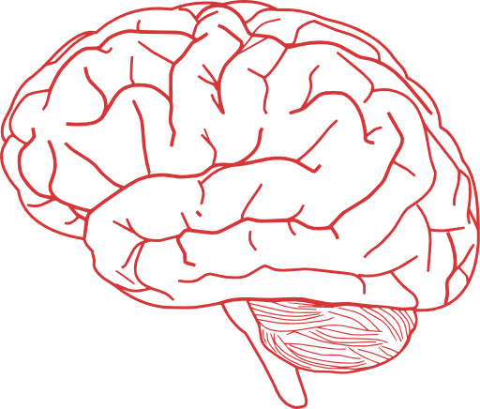

44 45 46 47 48

The following questions refer to the above diagram:
49. #44 & #45 refer to __________.
(A) oxygenated blood
(B) deoxygenated blood

50. The entire diagram represents a __________.
(A) Systemic circuit
(B) Pulmonary circuit

