Name ____________________________________________ Date ______________________ Period ________

E
E
AB
AC
AD
C
B
AE
- What type of bone is this?
  - Long bone
  - Short bone
  - Flat bone
  - Sesamoid bone
  - Irregular bone

For the following questions, match the numbered structures to the letters on the diagrams:

NOTE: Some structures share the same letter because they share the same answer.

(52) periosteum (57) medullary cavity
(53) spongy bone (58) compact bone
(54) epiphysis (59) diaphysis
(55) articular cartilage (60) sharpey’s fibers
(56) bone marrow

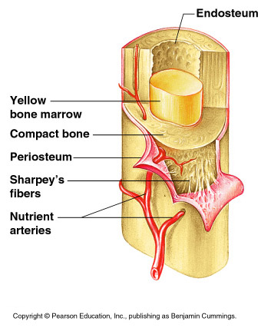
B
A
C
D

