DNA, Genes, Chromosomes, and Traits: What is the Relationship?

There are many terms and concepts in genetics. Let’s see if we can make some sense of them. Work in pairs. Using the evidence, figure out what is the relationship between: DNA, genes, chromosomes, and traits.

Evidence 1: Chromosomes in Humans and Other Species

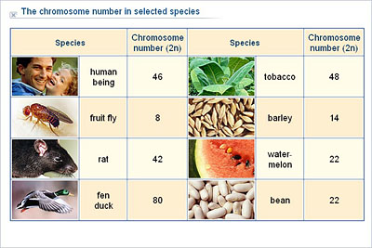
Scientists wanted to know how many chromosomes different organisms have in their cells. The table below shows their findings:

Then, they looked closely at 100 human cells with a microscope and found that the chromosomes were in the nucleus. In humans, there were 46 chromosomes that were paired up as shown below:
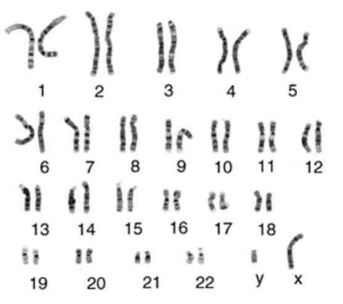
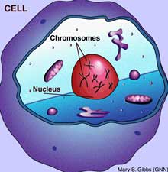

Answer the questions about Evidence 1 in your packet.

Evidence 2: Traits and Chromosomes

Studies of human genetics have shown that the genes for different diseases are found on different chromosomes. The table below illustrates some common diseases and the chromosomes on which their genes are found:

Gene for Trait | Chromosome
Deafness |  | 1
Alzheimer disease |  | 1
Autism |  | 2
Cystic Fibrosis |  | 17
Dwarfism |  | 3
Huntington |  | 4
Sickle Cell |  | 18
Albinism |  | 11
Lactose intolerance |  | 2
Breast cancer |  | 13 and 17

Evidence 1 showed that human chromosomes come in pairs. Scientists also found that each chromosome in the pair has the same genes on it. They found that people with albinism have the gene for albinism (Yes-Albinism) on both of their number 11 chromosomes. People who have the gene for No-albinism on either one of their number 11 chromosomes did not have albinism.

Answer the questions about Evidence 2 in your packet.

Evidence 3: DNA

Scientists know that DNA is found in the nucleus. They wanted to find out in which part of the nucleus DNA is located. They know the DNA molecule has a lot of phosphate atoms in it, so they used specialized equipment to find out where there are a lot of phosphates in the nucleus.

They found that most of the phosphate was in the chromosomes inside the nucleus. The scientists then extracted a chromosome from a human cell and looked at it under a very powerful microscope. The image below is a photo of what they saw:
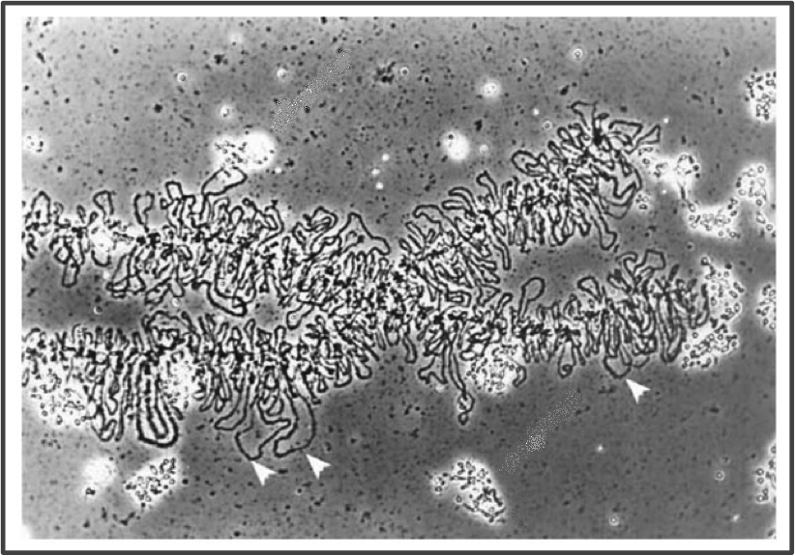

They concluded that the chromosomes were made of string-like DNA molecules, and that each chromosome was made up of one very long DNA molecule that is wound up like wool.

Answer the questions about Evidence 3 in your packet.

