Name ____________________________________________ Date ______________________ Period ________

E
E
AB
AC
AD
C
B
AE
- What type of bone is this?
  - Long bone
  - Short bone
  - Flat bone
  - Sesamoid bone
  - Irregular bone

For the following questions, match the numbered structures to the letters on the diagrams:

NOTE: Some structures share the same letter because they share the same answer.

(52) periosteum C (57) medullary cavity AE
(53) spongy bone AC (58) compact bone B
(54) epiphysis E (59) diaphysis AB
(55) articular cartilage AD (60) sharpey’s fibers D
(56) bone marrow A

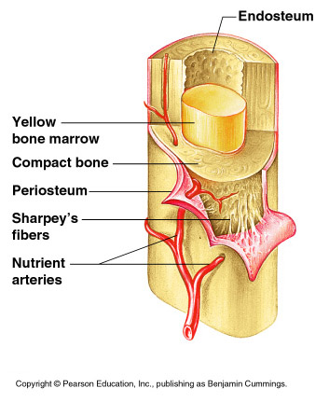
B
A
C
D

