- Which of the following can freely pass through a plasma membrane?
  - Calcium, sodium, potassium and chloride ions
  - Small proteins
  - Starch
  - Oxygen, carbon dioxide and water

Use the following information to answer the next 3 questions.
A biologist has three solutions; one is salt water with a concentration of salts just greater than that of a living cell. The other two are distilled water and pond water. She wants to determine which solution is salt water so she places several red blood cells into each solution.

- The blood cell in the salt water solution will

  - Swell and burst
  - Remain active and appear normal
  - Lose cell fluids and shrink
  - Immediately die but appear normal

- The blood cell in distilled water will

  - Swell and burst
  - Remain active and appear normal
  - Lose cell fluids and shrink
  - Immediately die but appear normal

- If the cells placed in the pond water neither swelled nor shrunk, the biologist could infer that:
  - The pond water has a similar concentration of salts as the cells
  - The pond water has a higher concentration of salts as the cells
  - The pond water would not be able to sustain living things
  - The membrane of cells are likely to have become impermeable

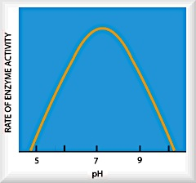
- Using the information in the graph on the right, one could infer that:
  - As temperature changes, enzymes are denatured
  - As pH changes, enzymes are denatured
  - There is no ideal pH that an organism is best suited to operate in
  - A pH of 9 shows a significantly higher rate of reaction than 6

- Prokaryotic organisms lack

- Genes
- DNA and RNA
- a nucleus
- cell membrane

- Which of the following is NOT part of the cell theory?
  - All cells have organelles.
  - All living things are composed of one or more cells.
  - All cells come from pre-existing cells.
  - The cell is the basic unit of structure and function of life.

- Which of the following phenomena is most likely due to cohesion?
  - The top of the lakes and rivers freeze.
  - The “Jesus lizard” can run across the surface of liquid water for short distances.
  - Adding salt to snow makes it melt.
  - Sugar dissolves in when mixed in water.

- What makes it possible for the water strider to walk on water?

  - surface tension
  - adhesion
  - capillary action
  - large heat capacity

- The molecules in the membrane through which large or charged particles may enter or leave the cell by are mostly made of:
  - Carbohydrate
  - Nucleic Acid
  - Protein
  - Phospholipids

- Kaylen is on the Rutgers’ soccer team. Right before a major game she checked her pulse. It was 60 bpm (her normal resting heart rate). Right after the game her pulse was 95 bpm. On the bus home, she checked her pulse again. It was 60bpm. The changes in Kaylen’s heart rate are an example of a(n):
  - Homeostatic response
  - Metabolic response
  - Immune response
  - Exercise response

- Which one is NOT an example of homeostasis:
  - Sweating to cool body down
  - Shivering to warm body up
  - Increased heart rate when exercising
  - Wearing clothes to keep warm

- Which one of the pictures below is most likely to result in the cell bursting?
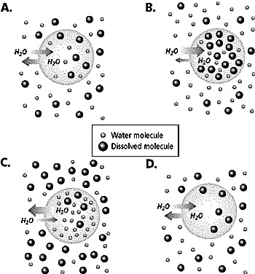

- If you go out to the FHS track and run 4 laps (about 1 mile), your core body temperature (internal body temperature) is likely to become

  - Slightly elevated
  - Slightly reduced
  - No different
  - Greatly reduced due to sweating

- A cell WITHOUT a buffer will:
  - Function normally if there is no change in pH
  - Function normally even if pH changes
  - Function normally using enzymes not affected by changes in pH
  - Cease to function because it will be unable to respond to changes in temperature

- What would be the most likely homeostatic response to a sudden drop in temperature?
  - Blood flow to the blood vessels would decrease
  - Blood flow to the blood vessels would increase
  - Hairs would lie flat
  - There would be no change because homeostasis means that an organism “stands still” at a “similar” level.

- All of the following are examples of diffusion EXCEPT:
  - The movement of sodium ions into the nerve against its concentration gradient
  - The movement of water across a membrane into a hypertonic solution
  - The spread of perfume throughout the room when a student uses scented lotion
  - Movement of oxygen from a red blood cell containing lots of oxygen to a body tissue containing little oxygen

- Concentration can be defined as:
  - The mass of a substance in a solution
  - The number of molecules in a substance compared to its mass and density
  - The number of molecules of a substance in a mixture in relation to another substance in the same mixture
  - The density of a substance when it is at room temperature

Use the following diagram and key to answer the following 2 questions.

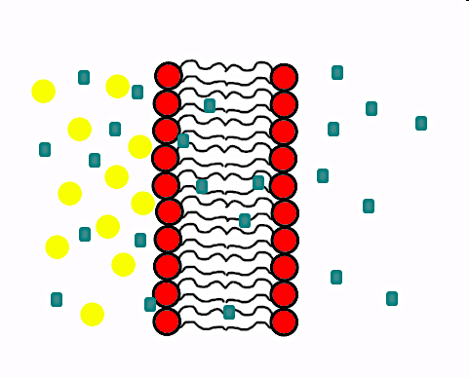
Key:
- large particles: will not pass through membrane

- small particles: freely passes through membrane

- The small particles shown are most likely to be

  - Not moving
  - Close to equilibrium
  - Moving from right to left only
  - Moving from left to right only

- The large particles shown cannot pass through the cell membrane. This is because:

  - The membrane is fully permeable.
  - The molecules are uncharged.
  - The molecules are too large.
  - The membrane is solid.

Free Response: Please read the directions following.

Answer all of the questions below.

- Laboratory Investigation

Change in pH of Different Solutions in Presence of Acid

Drops of Acid | pH of solution
 | Water | Potato | Buffer  (pH 9)
0 | 5 | 6 | 9
5 | 1 | 5 | 9
10 | 1 | 4 | 9
15 | 1 | 3 | 9
20 | 1 | 2 | 9
25 | 1 | 1 | 9
30 | 1 | 1 | 9

  - Plot the data on the graph paper provided to show how the change in pH varies for the different solutions with the addition of acid. Create a LINE GRAPH on the next page and make sure to label the axis and provide a graph title. (2)

  - Explain why there is no change in pH in the buffer when drops of acid are added. (1)

  - Compare the total change in pH for potato and water. Which of substance resists change in pH? Make sure to explain why that substance has the ability to resist change in pH. (2)

Graph Paper for Question #1

- Homeostasis
Homeostasis is a defining feature of all living things. It is a state of balance that all organisms must maintain to continue living. Explain in detail how our body maintains constant temperature.

  - What are the two mechanisms for warming our body up? Explain how they work. (2)

  - What are the two mechanisms for cooling our body up? Explain how they work. (2)

  - What would happen if the organism failed to keep pH or temperature constant? Be specific. Do not write: It will die! (1)

- Cell Transport
The cell membrane is a complex structure that regulates the passage of substances into and out of the cell. This enables the cell to maintain homeostasis.

- Which macromolecules make up the majority of the cell membranes? (1)

- Draw a diagram showing how they are arranged to form the cell membrane and label one of the parts. Make sure your cell membrane is at least 8 molecules long. (2)

- Of all the macromolecules we studied, what makes this macromolecule a good choice for creating cell membranes? (2)

