Name: _______________________________ Date: ___________ Y2 C L5 Color Blindness LH T2

ID: ________________________________ Teacher Name: ____________________________________Period: _______

STOP & THINK: Color blindness or color vision deficiency – is a condition in which a person is unable to differentiate between colors that other people can see. It is much more common in males than in females. Why do you think that is?

________________________________________________________________________________________________________________________________________________________________________________________________________________________________________________________________________________________________________________________________________________________________________

Inheritance of Color Blindness

Color blindness is an inherited condition. The most common type is red-green color blindness. Lets look at some evidence to figure out how color blindness is inherited and why it is more common in males.

Your job is to figure out how color blindness is being passed from one generation to the next. You need to come up with rules to explain how color blindness is inherited (just like Peter, Sara, and Theresa’s rule-models).

Work in pairs.

Evidence 1: Pedigrees
The three pedigrees on the next page show families with color blindness, a genetic disorder. Start by thinking about what alleles each person has. For each person in each family, write down their alleles in (or above) their square or circle. The key below can remind you about reading pedigrees.
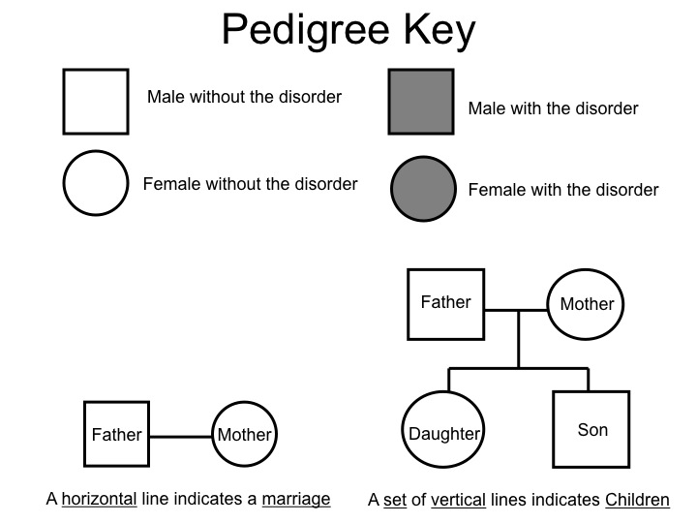

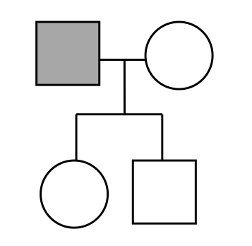
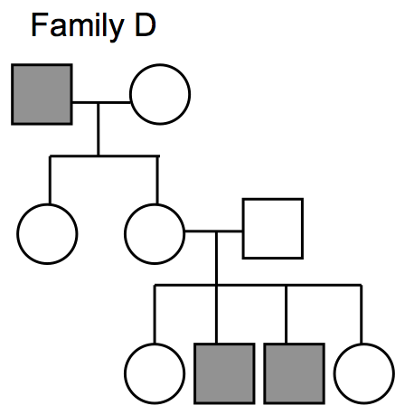
Evidence 1: Pedigrees
Evidence 2: Color blindness
2. For Family B, what can you predict about the alleles of the color blind father? Father’s alleles: ___________.Why are none of the children color blind? Be sure to give reasons for your answers!
______________________________________________________________________________________________________________________________________________________________________________________________________________________________________________________________________________________________________________________________________________________________________________________________________

______________________________________________________

3. For Family C, what would you predict about the alleles of the mother of the two color blind sons? Mother’s alleles: ____________. Why are none of the girls color blind? Give reasons for your answer.
____________________________________________________________________________________________________________________________________________________________________________________________________________________________________________________________

1. For Family A, why do you think only the male children are affected? Be sure to give reasons for your answers!
______________________________________________________________________________________________________________________________________________________________________________________________________________________________________________________________________________________________________________________________________________________________________________________________________

______________________________________________________

Scientists at the Howard Hughes Institute are studying color vision. They randomly selected 1000 adult men and 1000 adult women in each of five countries (U.S., England, Spain, China, and India). A total of 10,000 people participated in the study (with an equal number of men and women). They calculated the percentage of individuals in that sample who were diagnosed with color blindness.
They found that: 8% of the men and 0.6% of the women were colorblind.

3. What can you conclude from this evidence?
- More males are color blind than females.
- One’s biological sex has nothing to do with color blindness.
- Color blindness is recessively inherited.
- Color blindness is an extremely rare condition.

Evidence 3: Hemophilia
Hemophilia is a bleeding disorder in which blood does not clot normally. An individual with hemophilia may bleed for a longer time after an injury. Like color blindness, hemophilia is also more common in men. Historically, hemophilia was called the “royal disease” because many members of the European royalty suffered from it. The pedigree below represents the inheritance of hemophilia in the royal family of England.

4. What alleles for color vision do you think Queen Elizabeth had? ____________

5. Given the evidence you have seen, how do you think boys inherit hemophilia?
- From dad only.
- From mom only.
- From both parents.
- None of the above.

6. Write down your pair’s rules for how color blindness and hemophilia are inherited.

- These rules should build on the rules you chose in Lesson 2 (Sara’s rules) and on Mendel’s laws.
- These rules should describe how the alleles for color blindness are inherited.
- These rules should NOT contradict the rules you chose in Lesson 2 (Sara’s rules).

Rule 1: ___________________________________________________________________________________
Rule 2: ___________________________________________________________________________________
Rule 3: ___________________________________________________________________________________
Rule 4: ___________________________________________________________________________________
Rule 5: ___________________________________________________________________________________

Compare your rules with another pair.

Whole class discussion:

7. As a whole class discuss your rules and come up with an agreed-upon set of rules for your class. Write these rules down.

Rule 1: ___________________________________________________________________________________
Rule 2: ___________________________________________________________________________________
Rule 3: ___________________________________________________________________________________
Rule 4: ___________________________________________________________________________________
Rule 5: ___________________________________________________________________________________

8. STOP & THINK: Is is possible for a girl to be color blind? Explain.

________________________________________________________________________________________________________________________________________________________________________________________________________________________________________________________________________________________________________________________________________________________________________

